**Final Project for SW Engineering Class CSC 648-848 Fall 2018**

Team 01

Gator Trader

**Team Lead** - Marcus Mertilien

**Email:** marcusmertilien@gmail.com

**Front-End Lead** - Alex Ha

Athena Javier

Michael Phan

**Back-End Lead -** Raul Serrano

Daniel Martinez

Albert Shevchuk

**URL**: <http://gatortrader.herokuapp.com/>

Saturday, December 22, 2018

**Product Summary**

**Tired of dealing with strangers? Use Gator Trader!**

Are you a busy San Francisco State University student? Then we have an awesome new app that is going to help you purchase and sell goods online to nearby students just like you! Gator Trader was specifically designed by an outstanding crew of engineers to help SFSU students with their needs. Our application is user friendly, sophisticated, and super convenient. Only SFSU students now have the advantage to post, view, and message each other via our website making transactions simple so you can kiss that moving truck goodbye. Dealing with local students doesn't just make our product unique, but also an accommodation to you. Visit our page at: <http://gatortrader.herokuapp.com/>

Gator Trader Provides:

1. Easy website browsing.
   1. Browsing by category
   2. View item details
2. Guest users shall be able to search using our search engine.
   1. Filter search results
3. Simple user login and registration.
4. Registered users shall be able to contact sellers.
5. Registered users shall be able to post items for sale
6. All users shall be presented the Policy while they’re creating their account.
7. Registered users shall include contact information.
8. Registered users shall be able to look at the lists of the items they posted for sell.

**Milestone Documents**

**Milestone 1**

**SW Engineering CSC648/848 Fall 2018**

GatorTrader

Team 1

**Team Lead** - Marcus Mertilien

**Email:** marcusmertilien@gmail.com

**Front-End Lead** - Michael Phan

Athena Javier

Alex Ha

**Back-End Lead -** Albert Shevchuk

Raul Serrano

Daniel Martinez

**Milestone 1**

October 3, 2018

|  |  |
| --- | --- |
| Revision Date | Notes |
|  |  |
|  |  |
|  |  |
|  |  |
|  |  |
|  |  |

**1.     Executive Summary**

One of the top 10 reasons why people use the internet: Making money and marketing.  In the past decade, the number of users online has been skyrocketing. This has bolstered the exchange of information as well as the exchange of goods. Based on e-commerce, such as, eBay, craigslist, and Amazon, in the top most visited website. With the amount of different types of users each online marketing website get, they have variety of selection to choose on their website. But if we focus on one main target group, such as San Francisco State University students, we will develop one target focus, which is marketing to students who are known as “college broke students”. This website will not only help them to sell/buy items *easily*, but it will help them *securely* with every process. With *effortless* and *security*, students will need this to connect with other students faster. The Buy and Sell website will contain every student needs to make their life easier as a student:

1. This Buy and Sell website is intended for use by students attending San Francisco State University.
2. All information will be secured.
3. Students will be providing contact information when they sell items and will be able to contact the seller.
4. Students can browse through the website without creating an account.
5. Great Policy! Will help you make a smooth transaction.

We here at Gator Trader have put together an amazing team of developers to help build a platform where students can post their items for sale with ease.

**2. Persona and Use Cases**

**Personas**

1. A San Francisco State University (SFSU) student called John who is not good with computers but likes to shop. He prefers websites that are easy to navigate without getting lost on them. He mostly uses online shopping to buy what he finds interesting but doesn’t look for anything specific. He prefers to see recommendations or what is popular at the moment. Issues he has is that he would leave a website if it’s too hard to use or if he couldn’t easily find what he was looking for. Another issue is that his computer is old and slow and wouldn’t be able to run a website that uses a lot of ram and CPU usage.

2. Student 2 prefers when things go fast. He is skilled at working in computers so if everything works well then, he could navigate it easily. He is impatient and doesn’t like when things slow down or stop especially a website.  He also likes looking at the ratings of an object or item to know when something is good. In a website he wants to be able to find the item he wants quickly without clicking on too many links.

3. Student 3 likes to sell things online. He would buy things outside to sell at a later time for a higher price. He wants to be able to sell things easily and wants options to help manage the items that he has posted and see the messages from people who are interested. He also like shopping for cheap items. He wants to be able to see the cheaper items first in any category.

4. Student 4 is the admin of the website. He wants to stay out of trouble, so he regularly checks the website when he can to see if everything is okay. He also uses the website for personal use to buy things like the users who uses it. His issue would be when there are too many postings and he doesn’t have the time to check on all of them.

**Use Cases**

1. John wants to look to look online for things to buy and decides to go to our website. He browses through the different **categories**. He would **sort** by most sold or best sellers to see the things that have been purchased. Once decided on an item he would log in to message the buyer.

2. Student 1 is looking to check their sales online. They goes to the website, log in, and then click their username, which redirects to the seller dashboard. Here it will show the **posting status** as well as the option to add more and **messages** from potential buyers. There they add the info to their item as well as what category it would belong to.

3. Student 2 is the admin of the website. He checks the items posted to make sure they legal. Also gets rid of untrusted sellers by checking reports from that seller. If he sees an item that's illegal or abnormal like weapons, then he would delete that item and contact seller as per site policy.

**3. Data Definition**

1. **Guest User-** User without an account, can still browse the web.
2. **Registered User**- User with an account.
   1. **Members of a Registered User**
3. **Email**- an .edu email address.
4. **Image**- Items on sell.
5. **Admin** – User with administrative privileges
   1. **Employee of Gator Trader**
      1. **Admin Dashboard** – Flag to trigger admin status and show dashboard.
6. **Item** – Posted by a seller
   1. **Members of Item**
      1. Title
      2. Price
      3. Description
      4. Date

**4. Initial List of Functional Specifications**

1. Guest users shall be able to browse through the website.
2. Guest users shall be able to browse by categories.
3. Guest users shall be able to search on the search engine.
4. All users who wants to purchase an item shall create an account or login.
5. Registered users shall be able to contact any sellers.
6. All users shall be presented the Policy while they’re creating their account.
7. Registered users shall include contact information.
8. Registered users shall be able to look at the lists of the items they posted for sell and messages on their dashboard.
9. Registered users shall able to manage their account. Shall able to remove or edit postings.
10. Guest users shall be able to use sorted feature: Low to high prices, High to low prices, Alphabetical, etc.

**5. List of Non-Functional Specifications**

1. Application shall be developed, tested and deployed using tools and servers approved by Class CTO and as agreed in M0 (some may be provided in the class, some may be chosen by the student team but all tools and servers have to be approved by class CTO).
2. Application shall be optimized for standard desktop/laptop browsers e.g. must render correctly on the two latest versions of all major browsers: Mozilla, Safari, Chrome.
3. Selected application functions must render well on mobile devices
4. Data shall be stored in the team’s chosen database technology on the team’s deployment server.
5. No more than 50 concurrent users shall be accessing the application at any time
6. Privacy of users shall be protected and all privacy policies will be appropriately communicated to the users.
7. The language used shall be English.
8. Application shall be very easy to use and intuitive.
9. Google analytics shall be added
10. No e-mail clients shall be allowed
11. Pay functionality, if any (e.g. paying for goods and services) shall not be implemented nor simulated.
12. Site security: basic best practices shall be applied (as covered in the class)
13. Modern SE processes and practices shall be used as specified in the class, including collaborative and continuous SW development
14. The website shall prominently display the following exact text on all pages *"SFSU-Fulda Software Engineering Project CSC 648-848, Fall 2018. For Demonstration Only”* at the top of the WWW page. (Important so as to not confuse this with a real application).
15. **Competitive Analysis**

|  |  |  |  |  |
| --- | --- | --- | --- | --- |
| Features | Amazon | eBay | Craigslist | Gator Trader |
| Search | ++ | + | + | + |
| Selling | + | + | + | ++ |
| Delivery | ++ | + | + | ++ |
| Browse | + | + | + | + |

+ feature exists; ++ superior; - does not exist

Our product will offer some of the features other sites already have like Search, Browse, Sell, etc. However, our product has an advantage when it comes to Selling and Delivery because the communication is directly between seller and customer which will give customers the advantage of asking for a price reduction, or other accommodations that our competitors will not have. In addition, our Delivery system is faster than our competitors because the product will be delivered directly to the customer by the seller which means that the product can be delivered within ours and even minutes and the customer will not have to wait the usual two days or five days shipping time like in other companies.

**7. High-level System Architecture**

* Bootstrap
* React
* Express
* MySQL
* Google Chrome
* Safari
* Netlify
* Heroku
* AWS (Amazon Web Services)

**8. Team**

1. Marcus Mertilien -Team lead
2. Albert Shevchuk- Back end lead
3. Michael Phan - Front end lead
4. Alex Ha
5. Raul Serrano
6. Daniel Martinez
7. Athena Javier

**9. Checklist**

Team found a time slot to meet outside of class

-On Track

GitHub master chosen.

-Done

Team decided and agreed together on listed SW tools and deployment server

-Done

Team ready and able to use the chosen back and front-end frameworks and those who need to learn are working on it

-Done

Team lead ensure that all team members read the final M1 and agreed/understand it before submission

-Done

**Milestone 2**

**SW Engineering CSC648/848 Fall 2018**

GatorTrader

Team 01

**Team Lead** - Marcus Mertilien

**Email:** marcusmertilien@gmail.com

**Front-End Lead** - Michael Phan

Athena Javier

Alex Ha

**Back-End Lead -** Albert Shevchuk

Raul Serrano

Daniel Martinez

**Milestone 2**

October 18, 2018

|  |  |
| --- | --- |
| Revision Date | Notes |
|  |  |
|  |  |
|  |  |
|  |  |
|  |  |
|  |  |

**1. Data Definitions V2**

1. **Guest User-** A user without an account, can still browse the web.
2. **Item**- Books, Calculator, Furniture, etc. that is on sell.
3. **Messages**- Guest users are able to contact the sellers about the item posted for sell.
4. **Registered User**- User with an account can message other sellers about items.
5. **Email**- An .edu email address to show they’re SFSU students to buyers.
6. **Image**- Help view what/how/look the item on sell
7. **User record**- Registered users are able to keep track of what they posted.
8. **Admin**- User with special privileges; have the ability to remove posts from the site and generally enforce the Terms and Conditions of the site.
9. **Category**- Guest and registered users are able to search items by category.
10. **Drop Down Category**- Let users search easier by selecting by category.
11. **Search Engine**- Users are able to search any item on the search engine. Such as, “books”, “Calculator”, etc.
12. **Account**- Buyers shall register to complete a transaction.
13. *First Name and Last name*- the users’ Full name
14. *Birthday*- must be 18 years old and older to make a transaction on GatorTrader.
15. *Email*- must have a .edu email
16. *Phone Number*- Shall be included for easy and smooth transaction between buyers and sellers.
17. *Agreement*- Shall agree to GatorTrader policy to complete transaction.

**2. Functional Requirements**

* Priority 1
  + Post items
  + Login & Registration Page
  + Search by Category
  + Admin Dashboard
  + Detailed Search Page
  + Seller Dashboard
  + Password Encryption
  + Google Analytics
  + **Home Page**
  + **Lazy Registration**
  + **Image Upload**
  + **Website Disclaimer**
  + **Messaging Page**
* Priority 2
  + Search Field Validation
  + Thumbnails
  + New Tabs for Detail Pages

|  |  |  |  |  |
| --- | --- | --- | --- | --- |
| **Features** | **Amazon** | **eBay** | **Craigslist** | **Our Future Product** |
| Search | ++ | + | + | + |
| Selling | + | + | + | ++ |
| Delivery | ++ | + | + | ++ |
| Browse | + | + | + | + |

+ feature exists; ++ superior; - does not exist

Our product will offer some of the features other sites already have like Search, Browse, Sell, etc. However, our product has an advantage when it comes to Selling and Delivery because the communication is directly between seller and customer which will give customers the advantage of asking for a price reduction, or other accommodations that our competitors will not have. In addition, our Delivery system is faster than our competitors because the product will be delivered directly to the customer by the seller which means that the product can be delivered within ours and even minutes and the customer will not have to wait the usual two days or five days shipping time like in other companies. Registration establishes a level of security and safety for both parties. An admin has the ability to disclose communication messages between both parties to the law enforcement or the party itself.

**3. *UI Mockups & Storyboards***

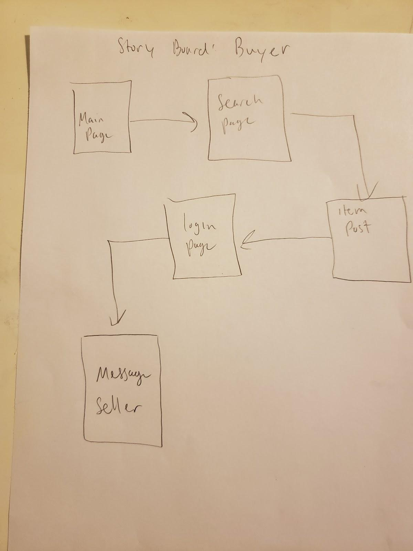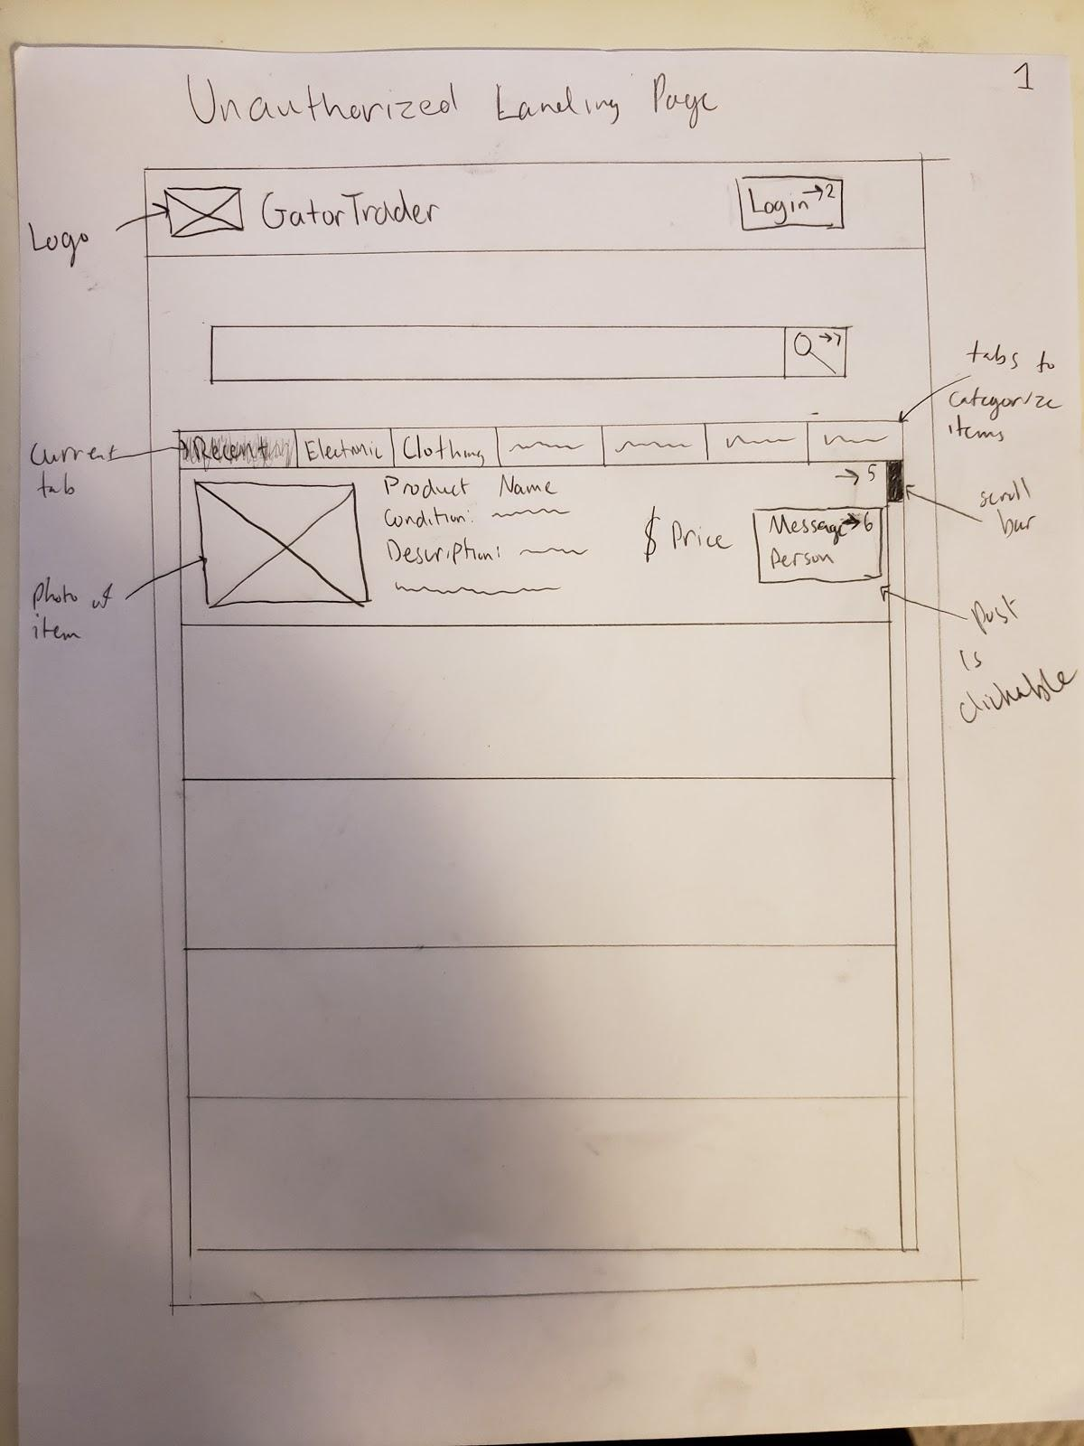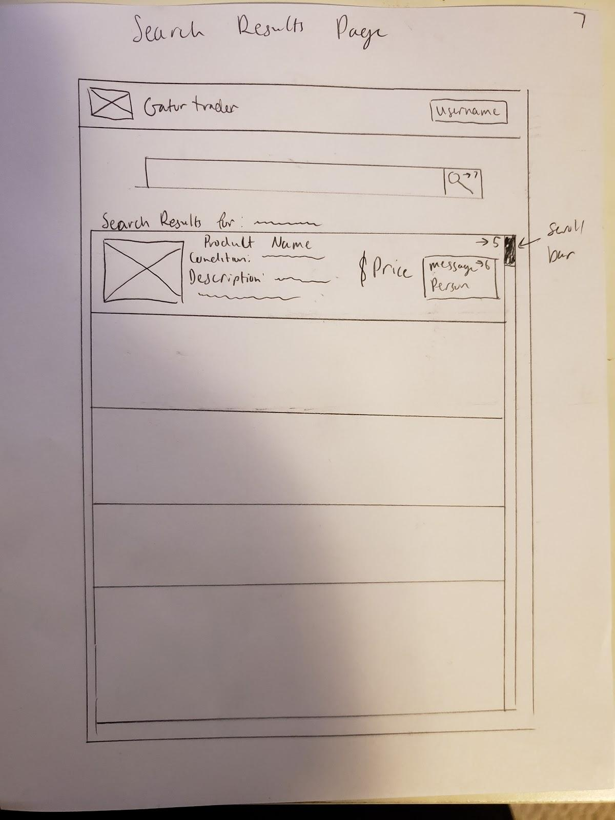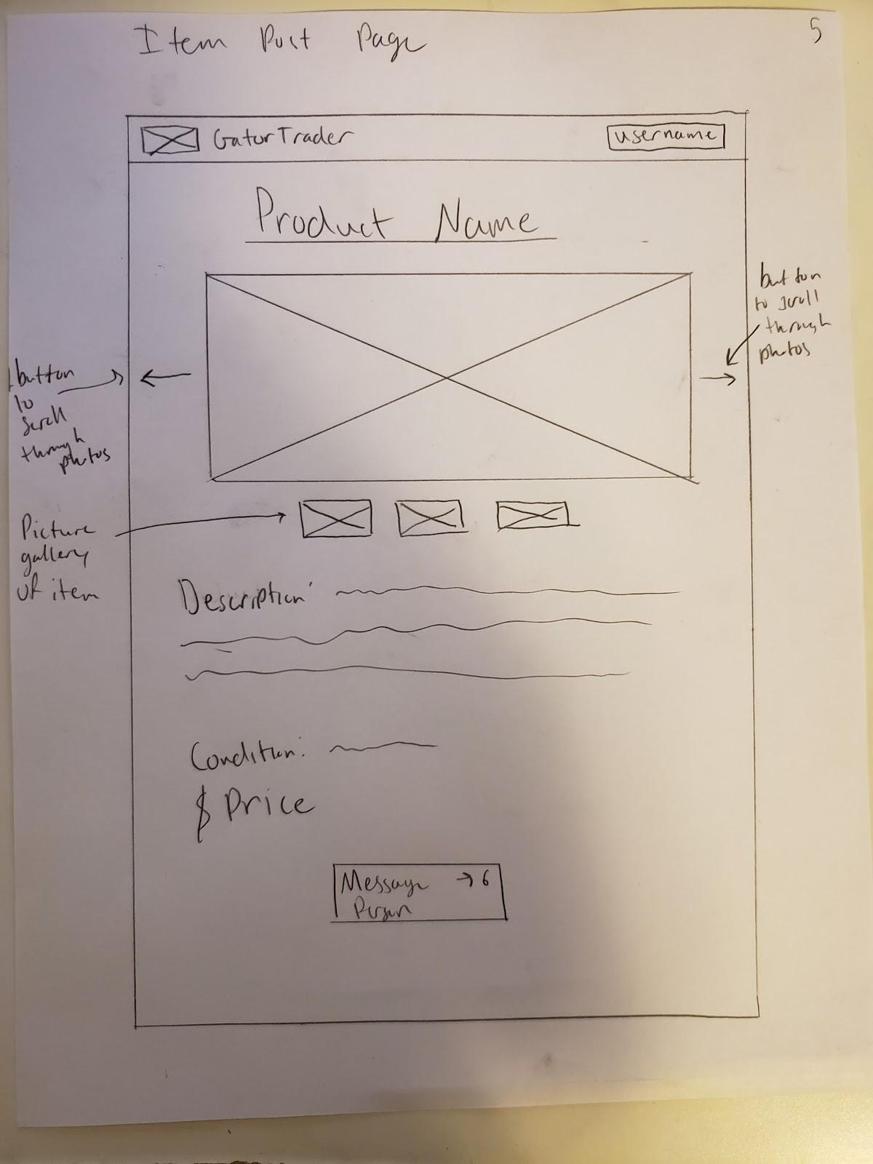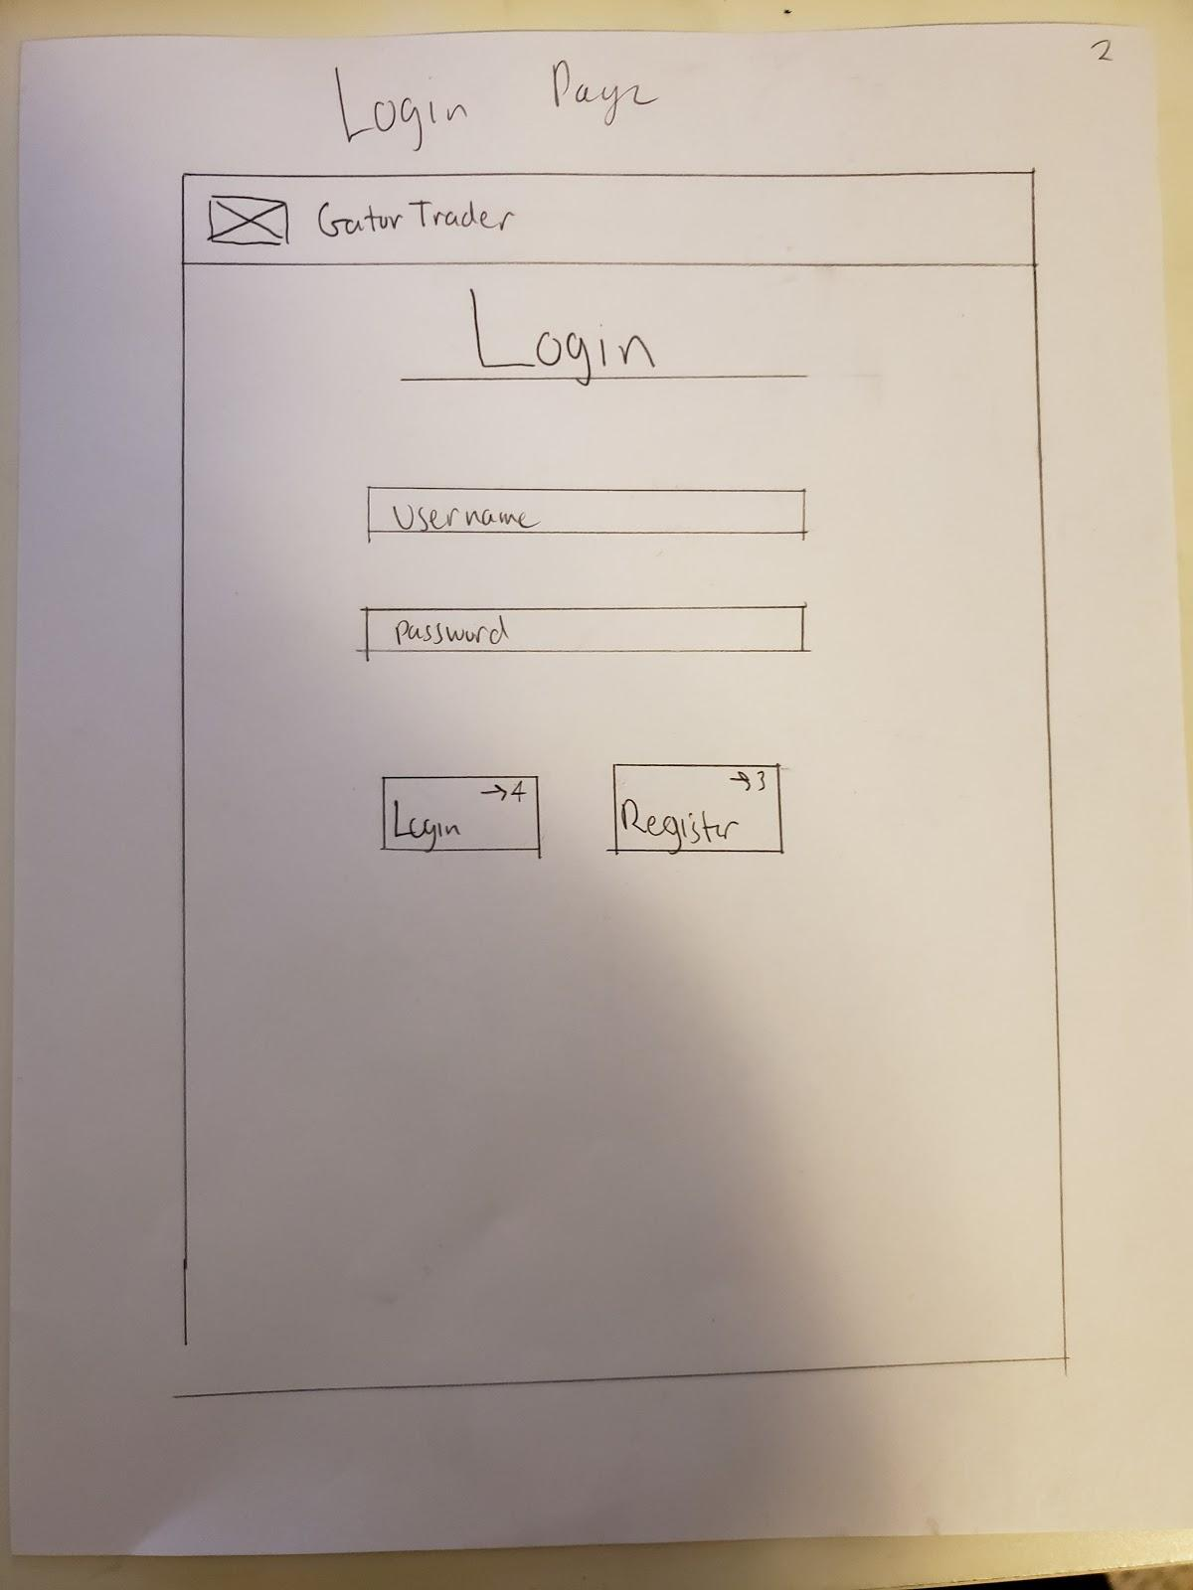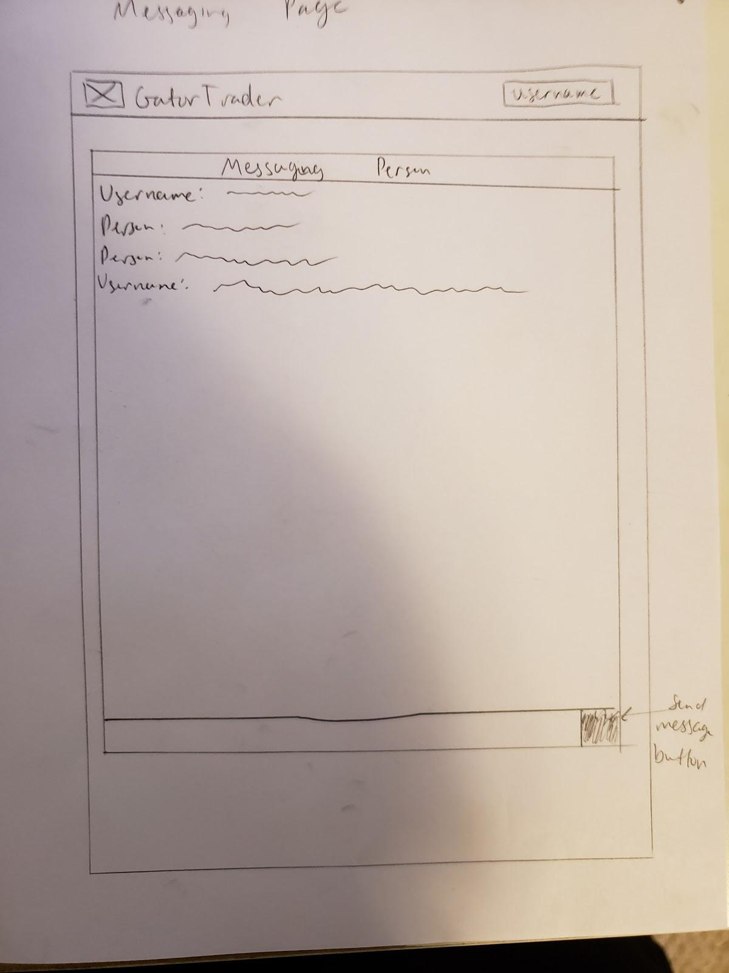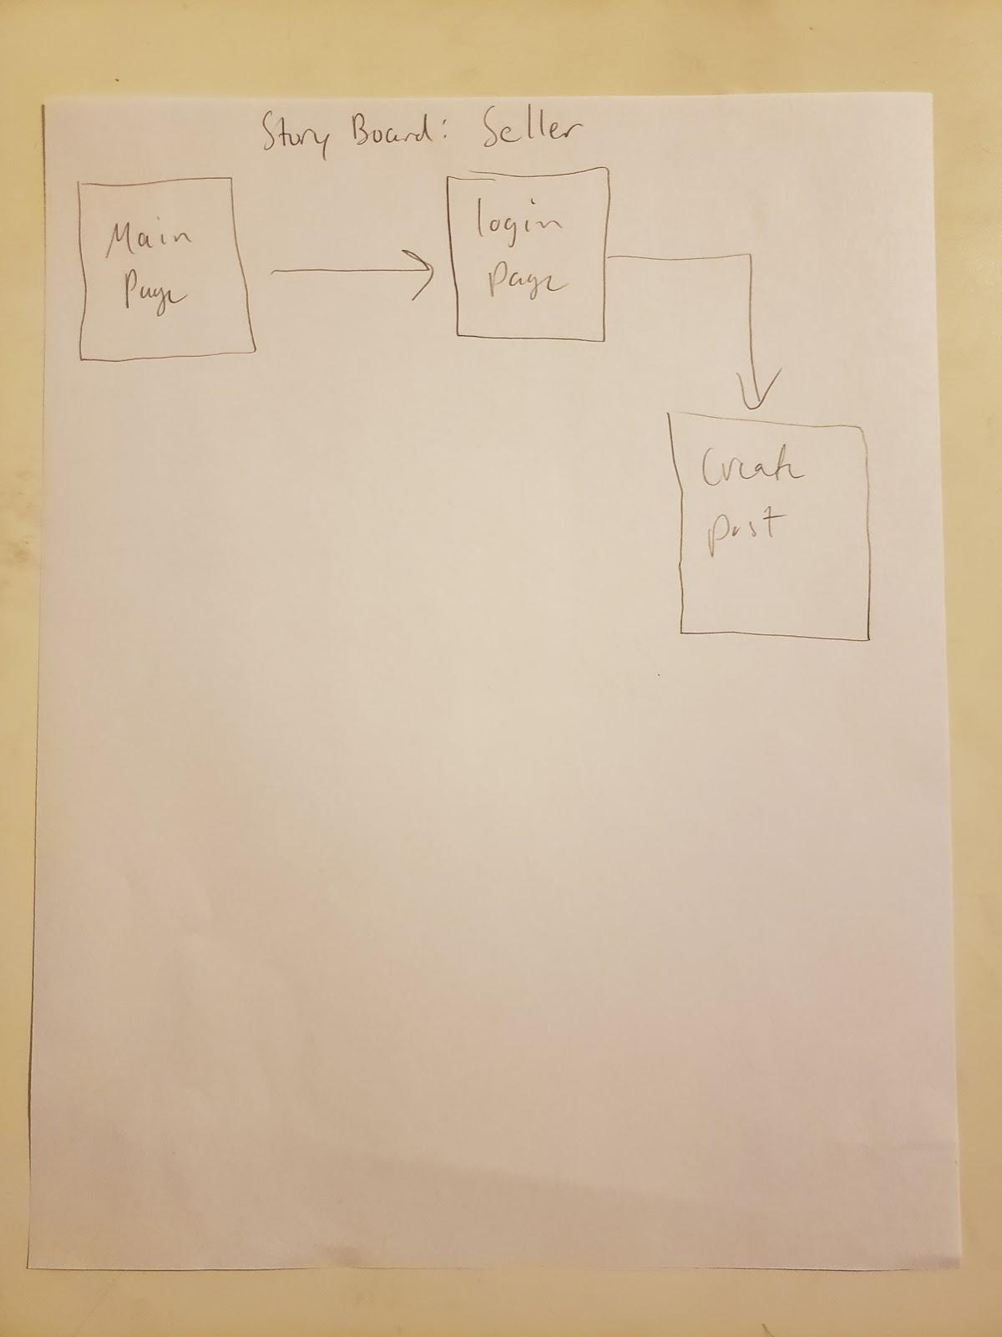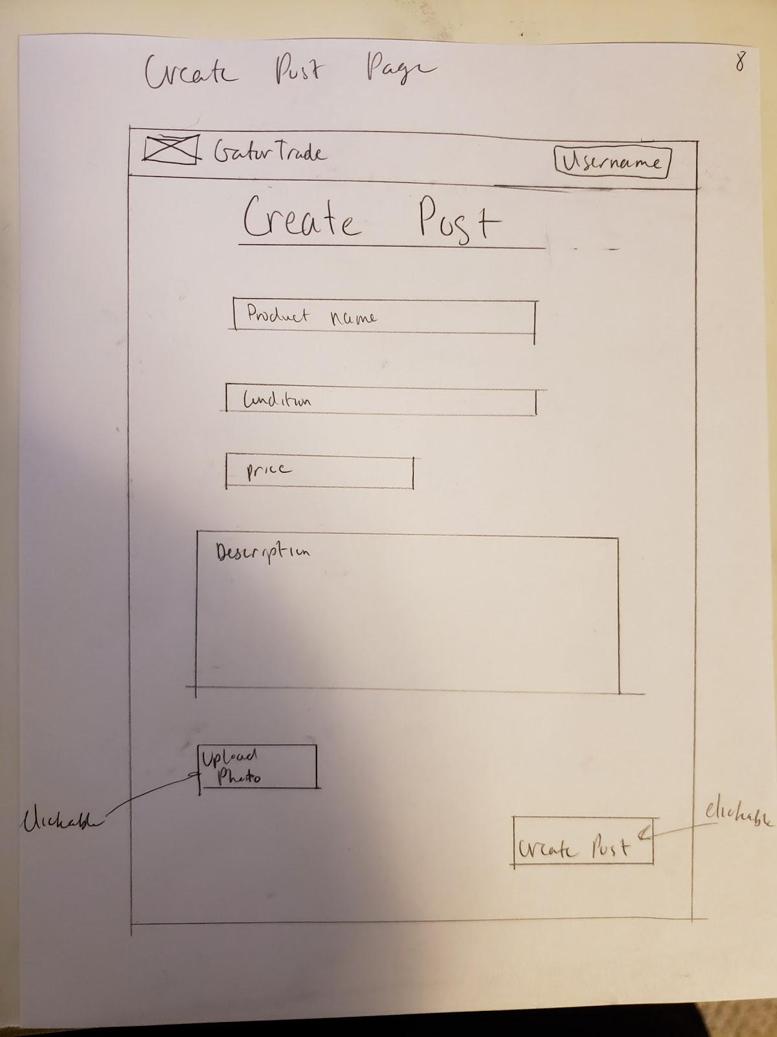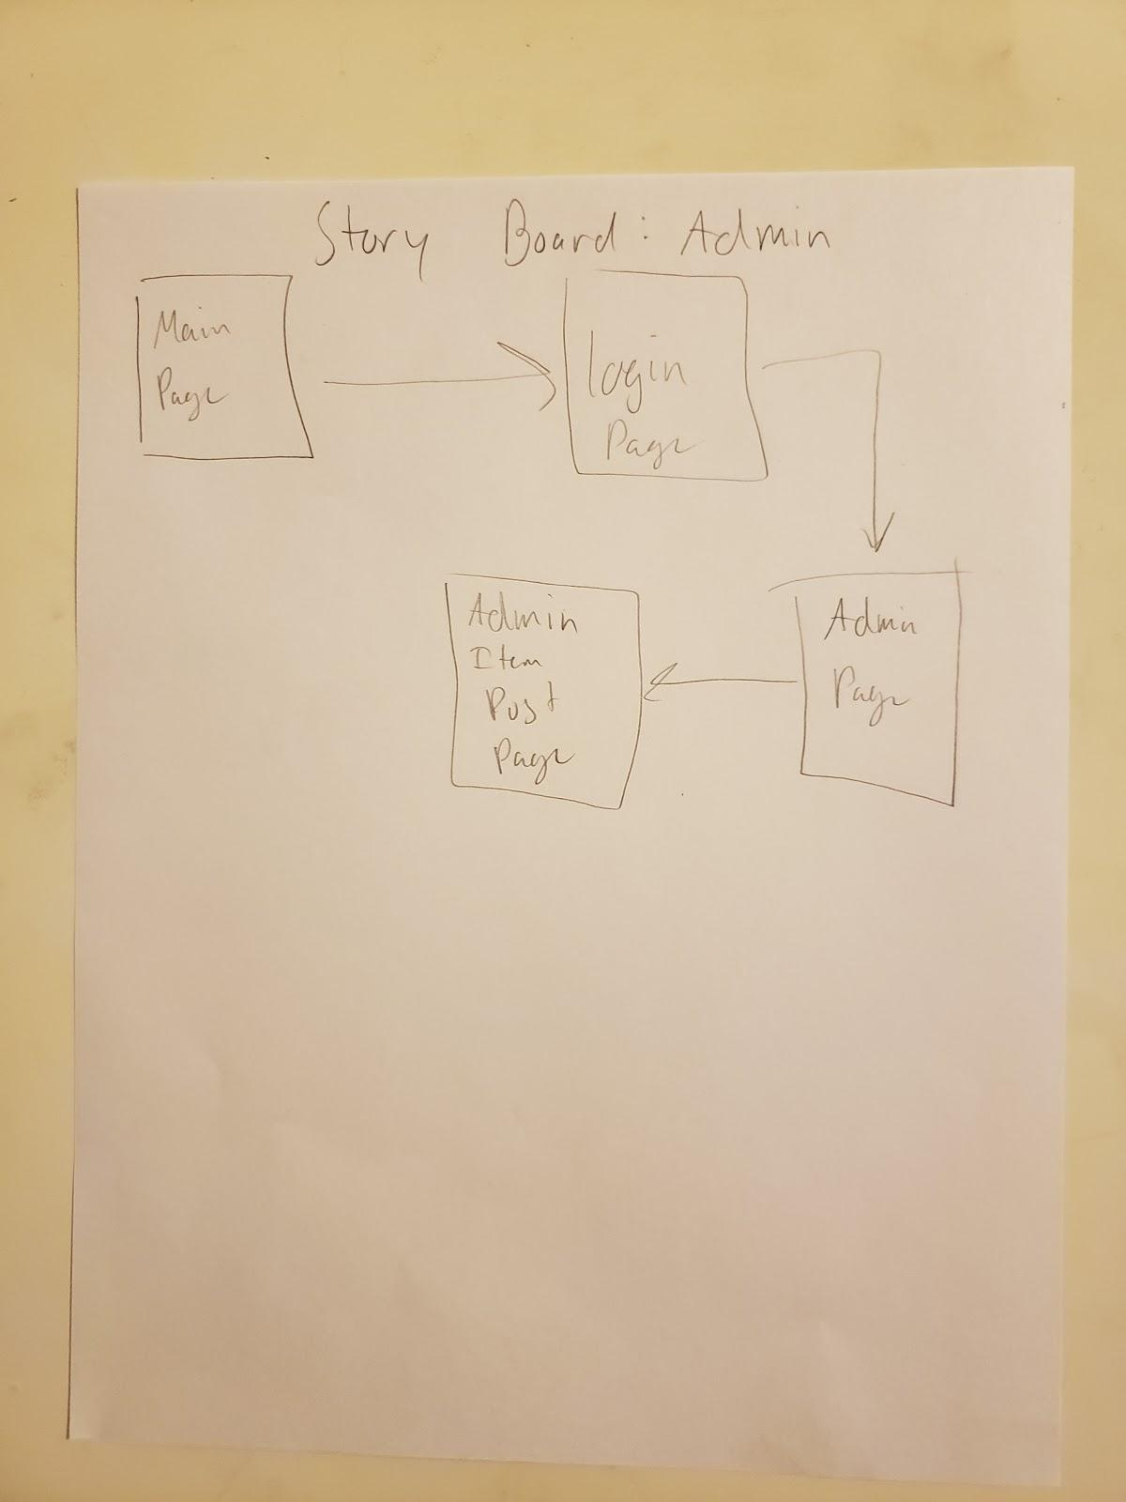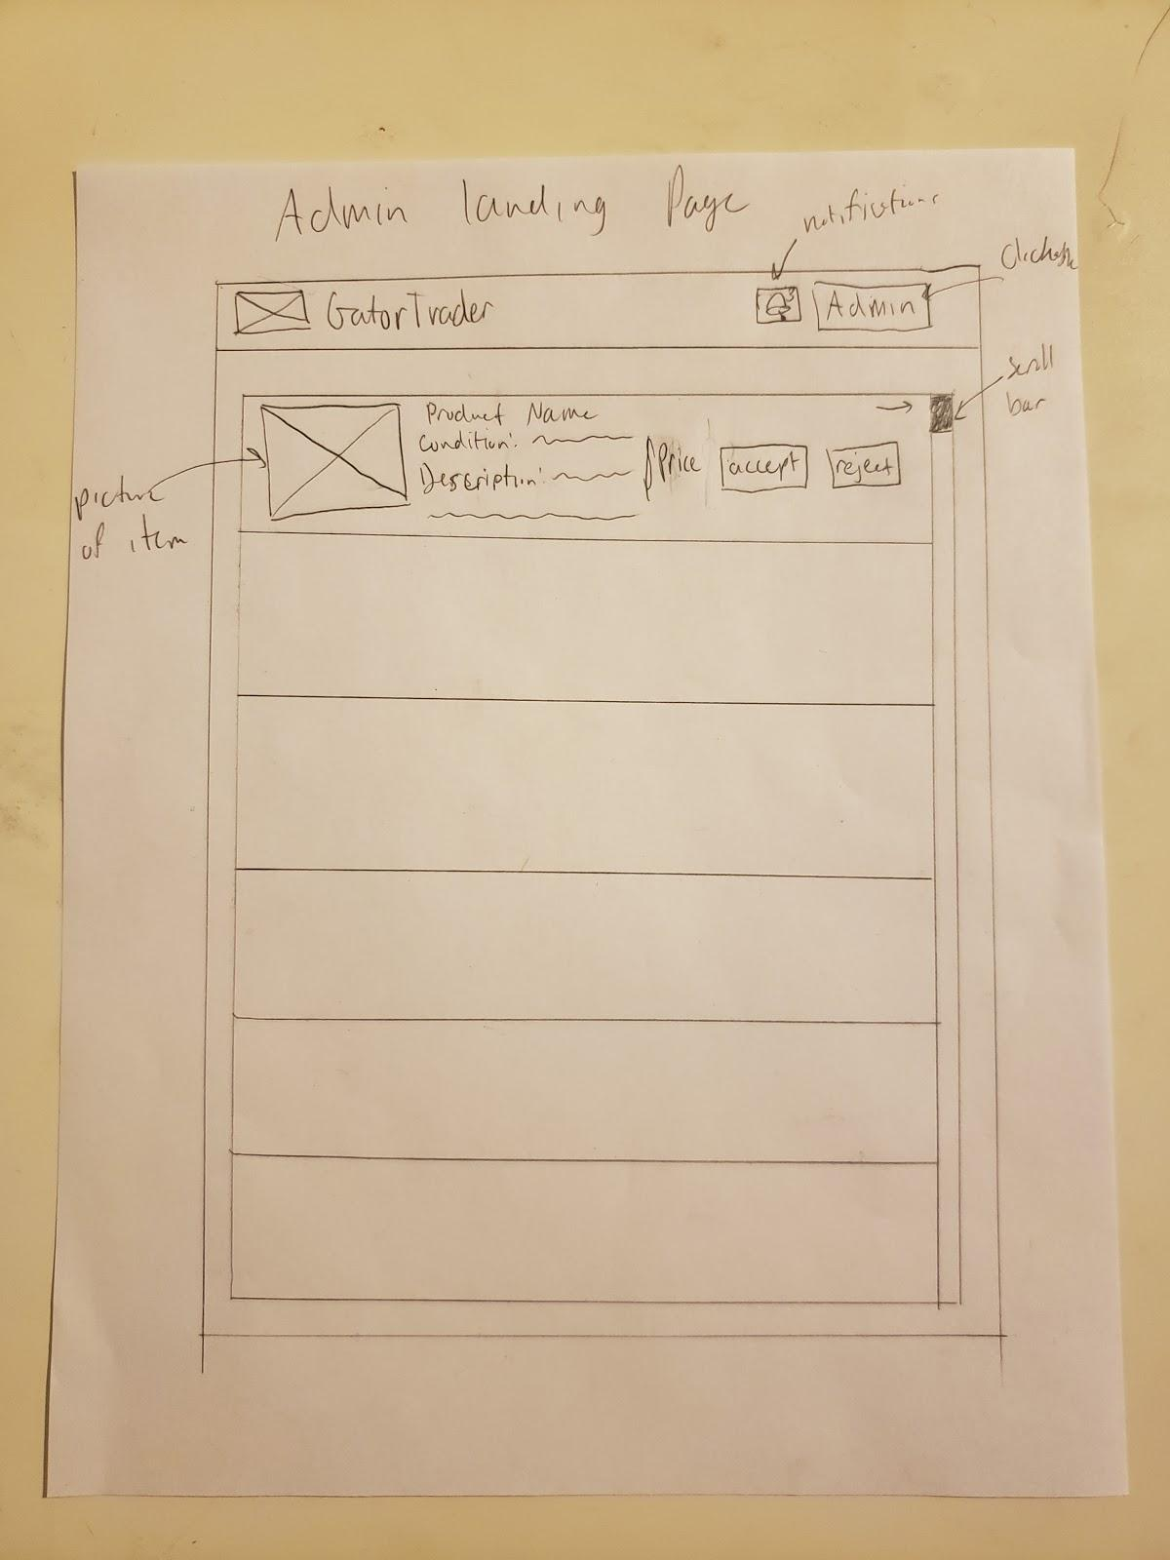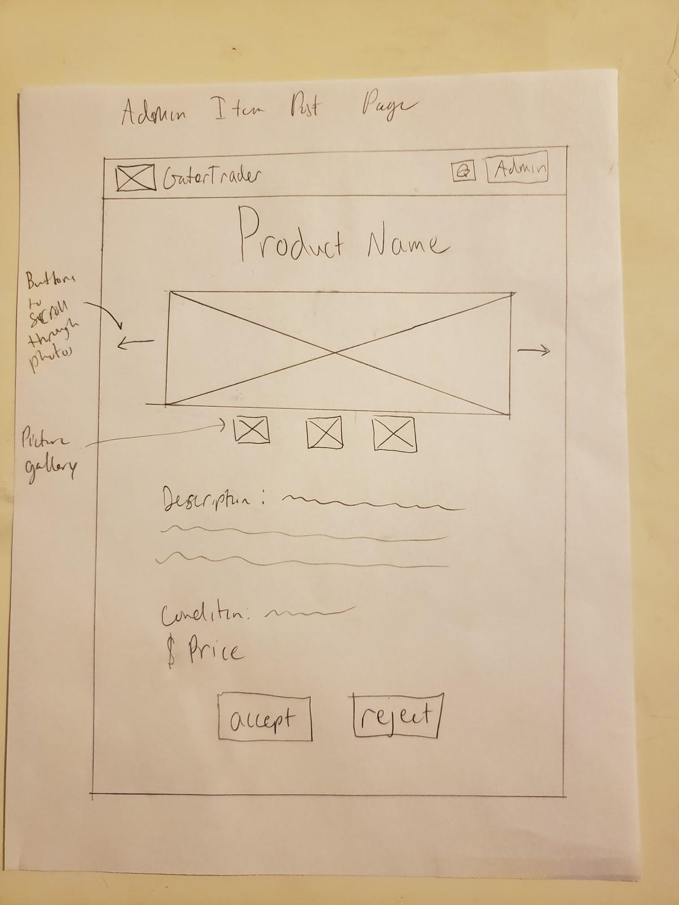

**4. *High level Architecture, Database Organization***

*DB organization:*

All the information will be in a database named users_database which contains 3 tables in the following configuration.

**Table 1: user_info : this table will be used to store all users registration information**

1.  user_id

 2. first_Name

 3. last_Name

 4. student_id

 5. userName

 6. user_password

 7. date_created

**Table 2: images: table to save photos of items each user is selling.**

1. item_id // this serves as a unique id for each image
2. display_name // this will be the named displayed on the page
3. item_category // this will be the category for the image
4. item_price
5. date_updated
6. item_name // this is the file name for the image
7. iem_type // this represents the image extension. example .png or .IMG
8. item_size //this has the size of the image file
9. foreign_id // this will connect user to image

**Table 3: user_chat: we will use this table to save messages between seller and buyer.**

  1. message_id_number

  2. message

  3. sender

4. foreign_id // this will connect user to chat

**Table 4: Search by %like**

1. item_id // this id will be connect to the image key to connect the mashup item to the image information.
2. item_mashup //the description title and category will be saved here as one to look for “Contains” or %like.
3. foreign_id // this will connect user to image

*Media Storage:*

* the images will be store in a folder in the server and then access with the information from the image table. also in some cases the image might be converted to save space

*Search/filter architecture and implementation*:

1. The user will be able to choose a category by name and/or input text to search for items that contain similarities (%like). for example the user will be able to just choose a category like Furniture and all items in that category will be displayed or the user can choose no category and just write a word like “bed” and it will display all item with the word bed in the title or description.
2. The user will be able to sort the search by newest to oldest, and by price.

*The database will be coded & organized as follows:*

The first table will contain the user registration information and it will contain an id number. The id number will auto increment for each new user. This id will also serve as a foreign key to connect images with users. the second table will contain all images from each user and it will also have an item_id to identify each picture. In addition, it will be connected with foreign keys to user_info table and Category table for easy access and retrieval. To add and get information from SQL we will use nodeAPI to connect to the database, we will use express to connect nodeAPI and the view code, and finally for our view code we will use react.

**5. *UML Diagram***

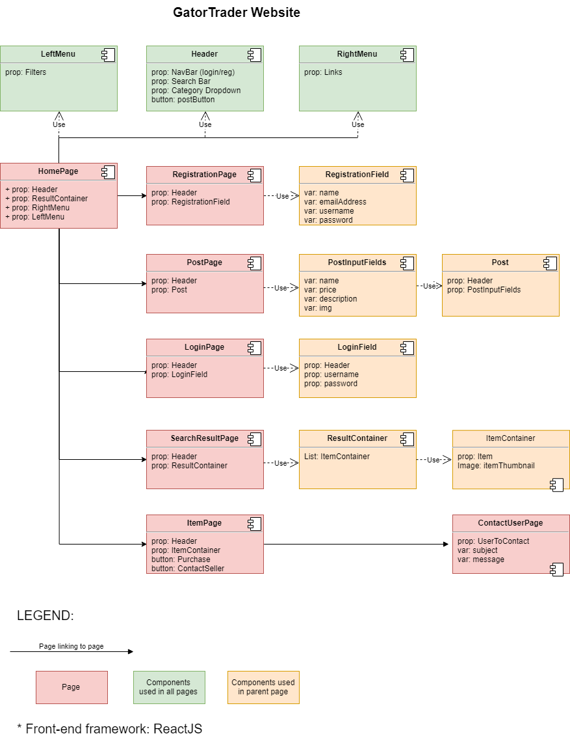

**6. *Key Risks***

* ***Scheduling Risk***: At this moment Team 01’s members are unable to meet outside of class as a team. Due to scheduling conflicts it is not possible to find a time in which all members of the team can be present for planning and group coding sessions.
  + ***Mitigation***: In order to solve this issue, team lead Marcus Mertilien, will rely heavily on front and back end leads to schedule meetings between their respective members. Team leads will then have a separate meeting in order to coordinate further efforts and keep the project on task.
* ***Skills Risk***: Our frontend framework React poses a potential risk since it is a relatively new framework. While our project depends on a stable build, React is different in the way it interfaces with the Document Object Model (DOM) and may be a challenge for the team to implement best practices. Asynchronous function calls would be an example.
  + ***Mitigation***: Team lead Marcus Mertilien, is most familiar with React, and his shared experience will help the team to overcome any potential roadblocks. React while new, is very well documented. Weekly check-ins will ensure team members stay on track.

**Milestone 3**

**CSC 648-848 section 01**

**Milestone 3 on-line review template**

**Fall 2018**

**\*\*\*\* Please fill out this template, convert it to PDF and mail as attachment to** [**Petkovic@sfsu.edu**](mailto:Petkovic@sfsu.edu) **by 11/16/18 noon. You will get feedback soon after. Anthony will do off-line review as per M3 Appendix II template \*\*\*\***

**In subject line of your e-mail put**

**“CSC 648-848 01 M3 online review Team N”**

**Team: 01 Lead: Marcus Mertilien**

**Date: November 16, 2018**

1. **Please briefly answer each question below:**
   1. *Teamwork*: is the team working out, any related issues
      1. *The team is having issues communicating*, not all members are active on Slack, informing others of their current work status. Trello was implemented to help combat communication issues, but again some team members are not taking full advantage of the communication tools provided.
   2. *Risks*: list all actual (not hypothetical) risks (schedule, technical, skills etc.) and plans how to resolve them OIR ask for help.
      1. *Technical*: We are having trouble figuring out how to pass data between pages using React. React is not originally designed for multiple pages, but for single page applications. We are looking for online solutions, but worst-case scenario we will fall back to a single page application model. We’ve also found that callbacks are one method of passing information between components.
   3. *Coding practices*: Have you decided which coding style to use and actually use it? Make sure you use header comments and some code inline comments too.
      1. *We have yet to decide on a defined coding style, however as team lead I am trying to enforce some basic structure to minimize a drastic refactor*.

* 1. *Usage of proper SE code management practices in github*

Do you have master branch that contain only tested code and is carefully managed?

* Yes, master is locked and controlled by the team lead. Once all testing and development is finished for a milestone, staging is then merged into master.

Do you have development and feature branches

* Yes, each developer is required to branch from our staging branch first before pursuing new features.

Are you doing any code review?

* Yes, developers are strongly encouraged to create a pull request before merging code into staging. This provides a chance for code reviews, time permitting.

Are your comments on github code commits meaningful to reflect enough details?

* Yes, most comments are meaningful enough that you can understand the changes between commits. If time permits I would like to squash the commits for a cleaner working tree.

Are all team members committing on github individually

* Not all team members have contributed meaningful code. Those who have contributed have made meaningful commits and followed the merging process.

* 1. *How did you address site security and safe coding practices:*

Are PW encrypted/hashed

* Passwords will be encrypted but did not make it in time for this milestone. Storing passwords in plain text is an obvious mistake, and a production version will enforce password encryption.

Are you doing any input validation on search text entry as specified (<40 alphanumeric characters?

* The search bar is currently limited to 20 characters of input. We will also apply character limits to all input fields.
  1. *Digital content* (e.g. images, video) – have you obtained enough (total of 30 or so) images for e.g. 4-5 product categories for your demo, royalty free
* The database as it is currently is only populated with 10 or so items. Over the Holiday break the database will be populated for proper testing.
  1. Anything else
* Based on this milestone, I am not happy with the performance of Team01. I believe team members do not understand the gravity of this project, and subsequently have made this class a last priority. Communication has become extremely difficult. Deadlines have been ignored, and productivity has suffered. While the work load is now heavy, it is doable with the members who are contributing.

1. **Provide URL to home page, running from your server so it can be tested (ensure UI implementation is responsive)**
   1. [**http://gatortrader.herokuapp.com/**](http://gatortrader.herokuapp.com/)

1. **Provide PDF screen shots, ONE PER PAGE, of the following screens (they have to be real coded pages but not necessarily connected to back end)**

* Home page

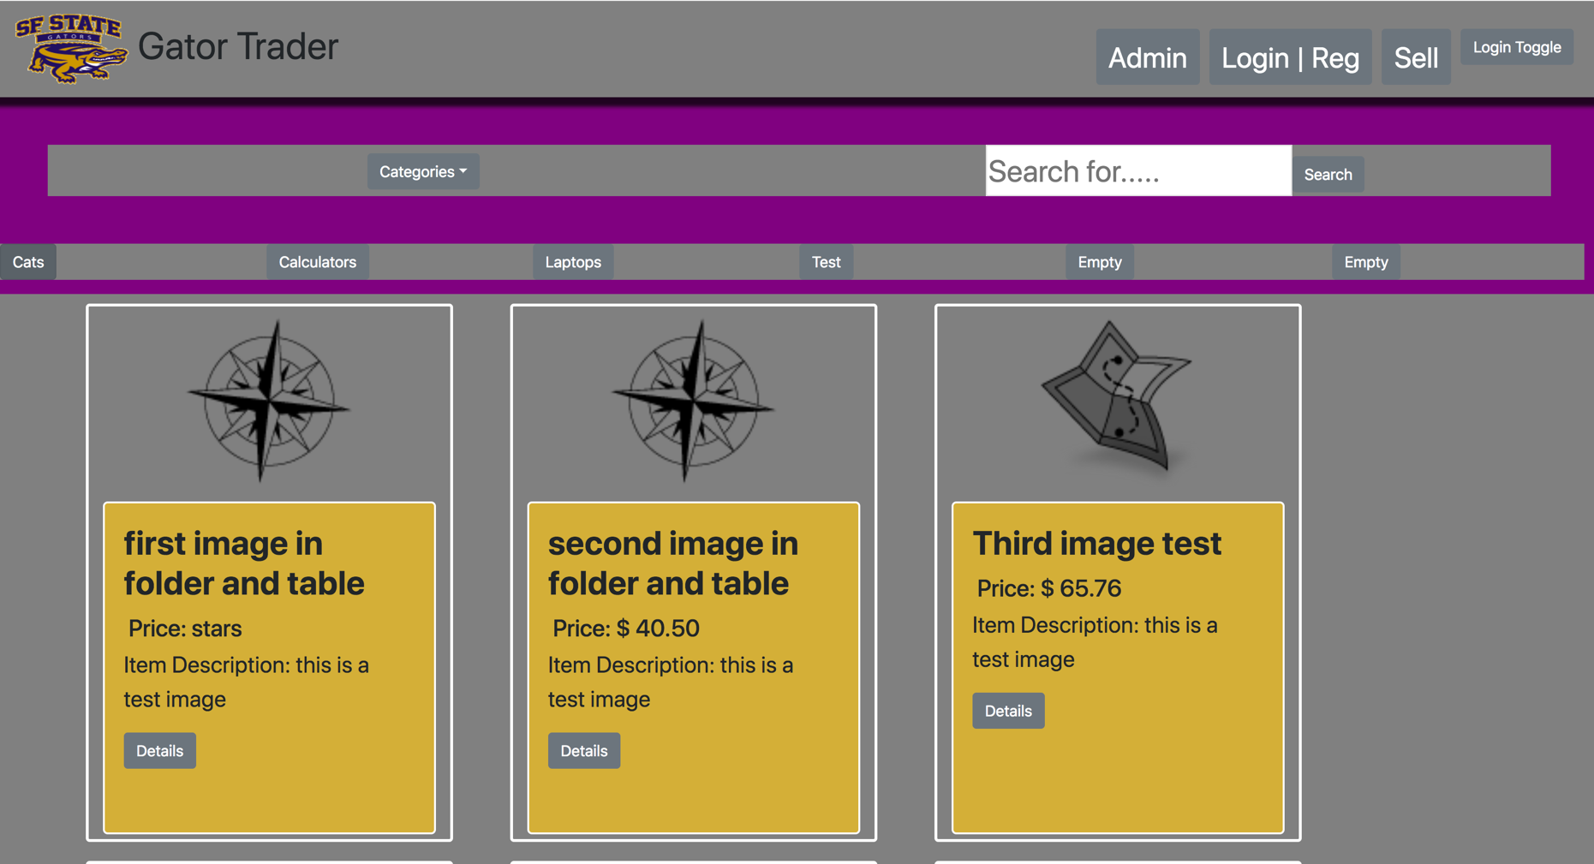

* 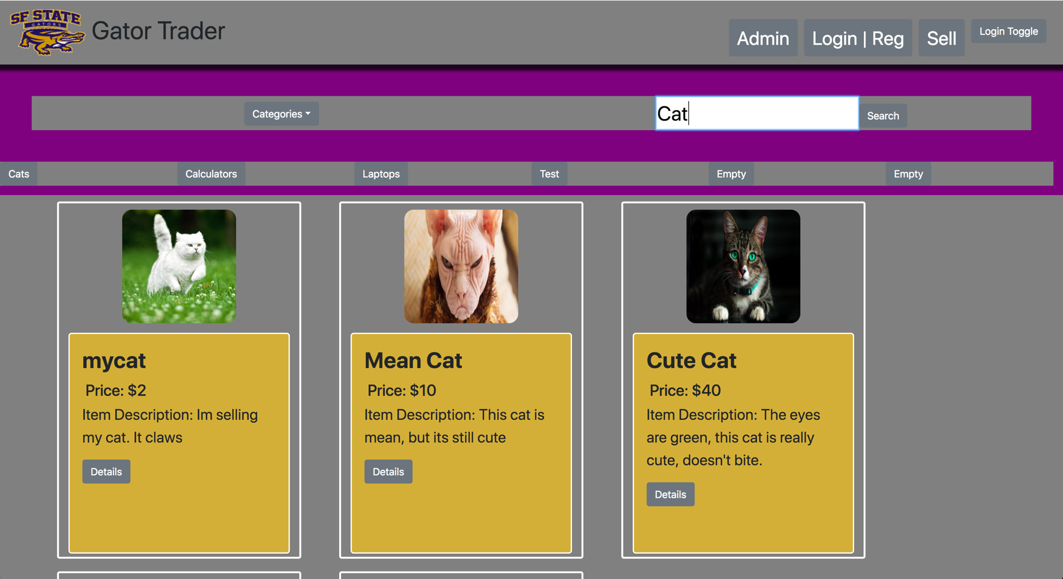Search results (NOTE: search parameters chosen by user have to be persistent)
* 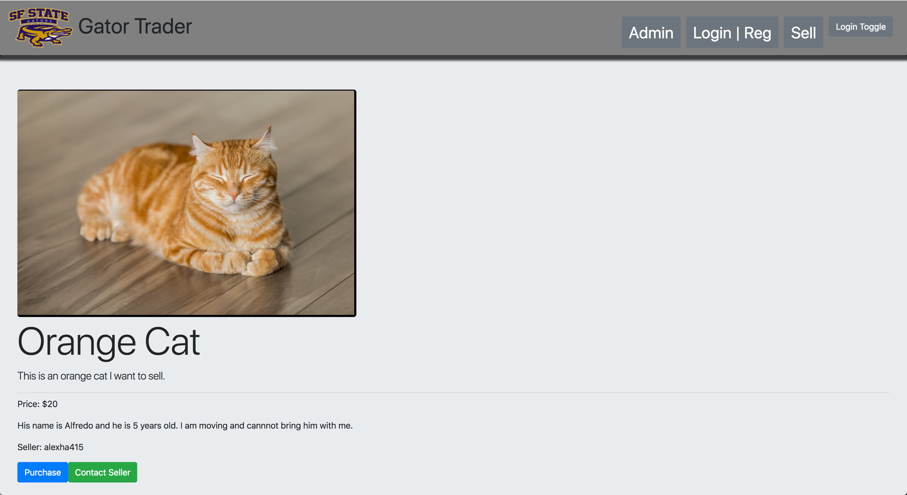Item details
* Messaging/contact seller

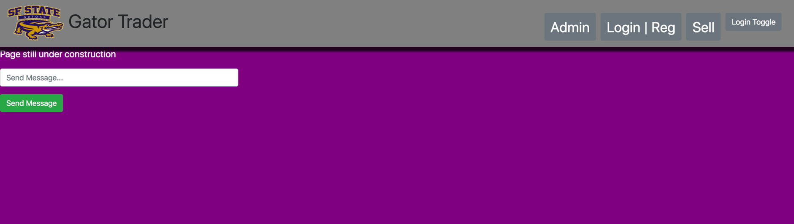

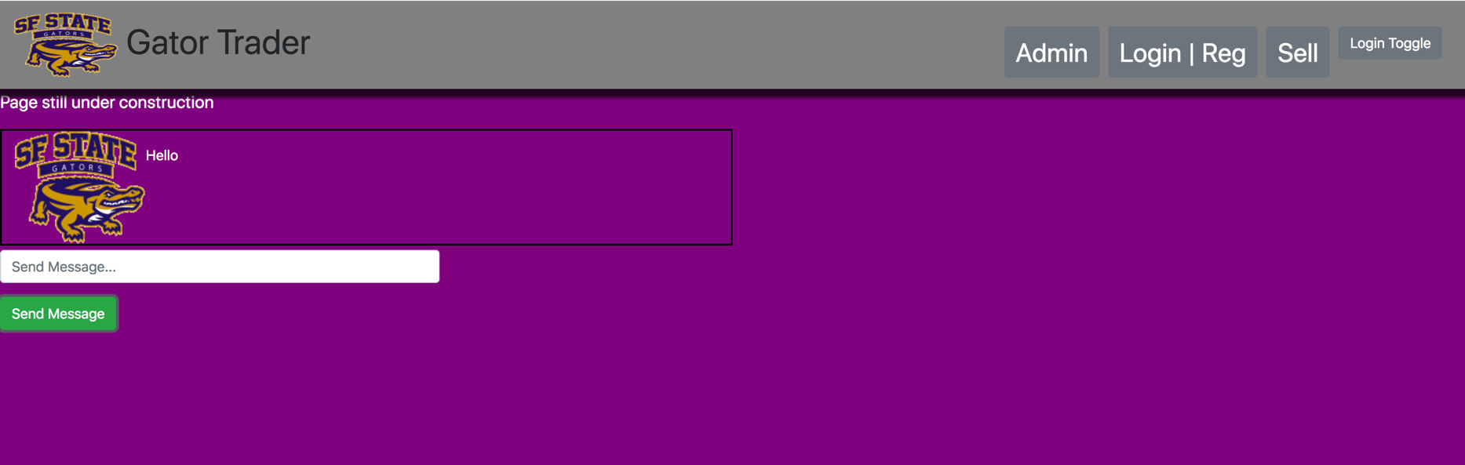

* Item posting

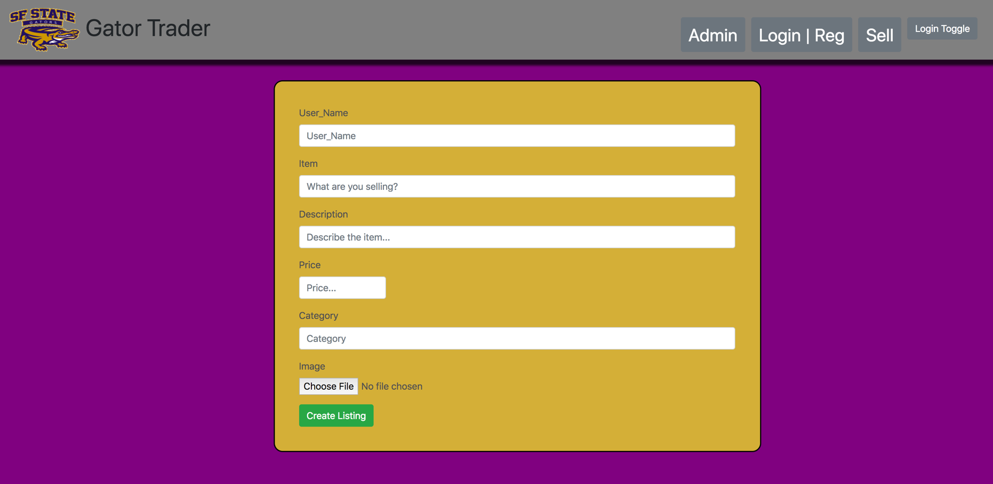

* 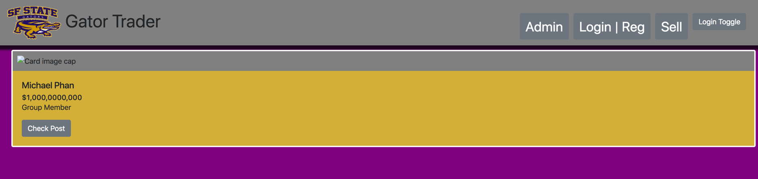Seller dashboard
* Admin dashboard

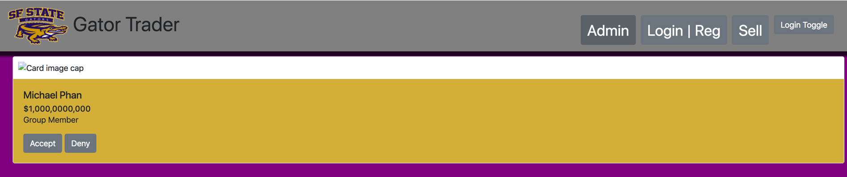

1. **List all major DB tables you have implemented and list their items**
   1. 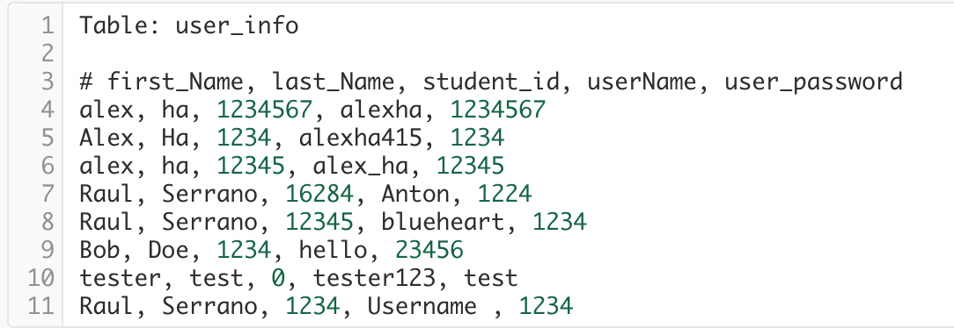
   2. 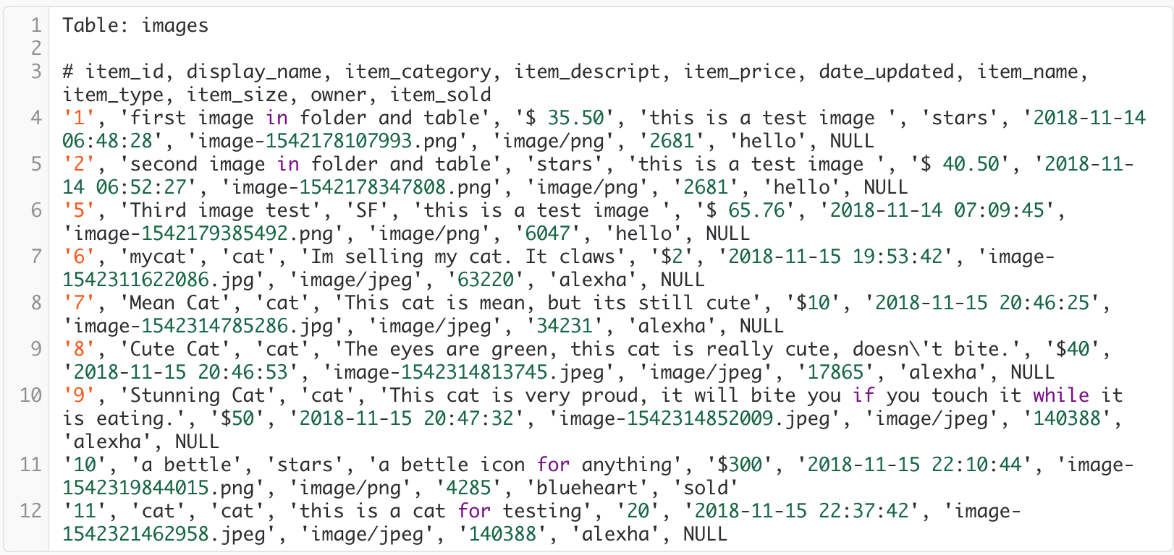
   3. 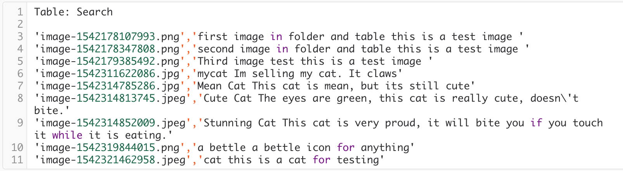
2. **List of requested P1 functions – provided by your CEO**

The flowing functions constitute minimal P1 list and you must implement and test them for December demo

* Home page
* Search(with search text validation)
* Search results
* Item details
* Log in and registration
* Item posting
* Message from buyer to seller
* Seller dashboard (for seller items and messages)
* Admin dashboard (backup is to use DB native admin tool but must show ability to approve posted images)

**Milestone 4**

**SW Engineering CSC648/848 Fall 2018**

**GatorTrader**

Milestone 4: Beta Launch

Team 01

December 2, 2018

**Team Lead** - Marcus Mertilien

**Email:** marcusmertilien@gmail.com

**Front-End Lead** - Alex Ha

Athena Javier

Michael Phan

**Back-End Lead -** Raul Serrano

Daniel Martinez

Albert Shevchuk

|  |  |
| --- | --- |
| Revision Date | Notes |
| 12/20/18 | Edited/Rearranged 2.2 with 3.3 and fixed some grammatical errors. -Albert |
|  |  |
|  |  |
|  |  |
|  |  |
|  |  |

**1. Product Summary**

**Tired of dealing with strangers? Use Gator Trader!**

Are you a busy San Francisco State University student? Then we have an awesome new app that is going to help you purchase and sell goods online to nearby students just like you! Gator Trader was specifically designed by an outstanding crew of engineers to help SFSU students with their needs. Our application is user friendly, sophisticated, and super convenient. Only SFSU students now have the advantage to post, view, and message each other via our website making transactions simple so you can kiss that moving truck goodbye. Dealing with local students doesn't just make our product unique, but also an accommodation to you. Visit our page at <http://gatortrader.herokuapp.com/>



**Thanks for looking :)**

**1.1 Functional Commitments**

1. Guest users shall be able to browse through the website.
2. Guest users shall be able to browse by categories.
3. Guest users shall be able to search on the search engine.
4. All users who wants to purchase an item shall create an account.
5. Registered users shall be able to contact any sellers.
6. All users shall be presented the Policy while they’re creating their account.
7. Registered users shall include contact information.
8. Registered users shall be able to look at the lists of the items they posted for sell.
9. Registered users shall able to manage their account. Shall able to remove or edit postings.
10. Guest users shall be able to use sorted feature: Low to high prices, High to low prices, Alphabetical.

**2. Usability Test Plan**

**2.1 Test Objectives:**

* Post ad with Tagged Image File format (.tif) image using Windows 10 on the latest Internet Explorer Browser.
* Post ad with Graphics Interchange Format (.gif) image using Windows 10 on the latest Mozilla Firefox Browser.
* Post ad with Joint Photographic Experts Group (.jpg) image using Windows 10 on the latest Opera Browser.
* Post ad with Portable Network Graphics Image (.png) image using Windows 10 on the latest Google Chrome Browser.
* Post ad with Tagged Image File format (.tif) image using Mac OS High Sierra on the latest Google Chrome Browser.
* Post ad with Graphics Interchange Format (.gif) image using Mac OS High Sierra on the latest Opera Browser.
* Post ad with Joint Photographic Experts Group (.jpg) image using Mac OS High Sierra on the latest Mozilla Firefox Browser.
* Post ad with Portable Network Graphics Image (.png) image using Mac OS High Sierra the latest Internet Explorer Browser.

**2.2 Questionnaire**

|  |  |  |  |  |  |
| --- | --- | --- | --- | --- | --- |
|  | **Strongly Agree** | **Agree** | **Neutral** | **Disagree** | **Strongly Disagree** |
| **The test plan wes simple to read and follow** |  |  |  |  |  |
| **The application was simple to navigate** |  |  |  |  |  |
| **This was a thorough Test Plan** |  |  |  |  |  |
| **Any Comments?** |  | | | | |

**3. QA Test Plan**

For the useability test portion we chose the Upload Image function to be thoroughly tested. The plan it to try two operating systems: Windows 10 version 1809 and Mac OS High Sierra Version 10.13.6. In conjunction 4 different popular web browsers will be used at a random order desired by the technician which are stated to be Firefox Version 70.0 Nightly, Google Chrome Version 70.0.3538.110, Opera Version 57.0.3098.76. Internet Explorer Version 11.

The starting point will be <http://gatortrader.herokuapp.com/> which is the home page and the user will post four items.

**3.1 Test Objectives**

The objective is to comprehensively test the upload function of GatorTrader in order to ensure that upload results are fully functional and display the image on the posting page.

**3.2 System Setup**

Processor: Intel Quad Core i7

Ram: 16GB Ram

Operating System: Dual boot: Mac OS X High Sierra, Windows 10

Browser 1: Google Chrome

Browser 2: Mozilla Firefox

Browser 3: Internet Explorer

Browser 4: Opera

URL: <http://gatortrader.herokuapp.com/>

**3.3 Feature to be Tested**

The intended user is a qualified Q&A personnel who is also a student. They shall navigate to the top left corner where the gray “Sell” button is and click it. Assuming they have not created an account, the user will be prompted to register. User will have to input their First Name, Last Name, SFSU Student ID, Username, and Password. Then click on the Green Box below named “Register” and they will be redirected to the posting page. Here the user will input their Username, Name of the item they are selling, Description, Price, Category, and a upload box at the very bottom that will allow the user to browse their device and select an image to go along with the post. The user will create 4 ads with a Windows Machine and 4 ads with a Macintosh. The purpose of this is to test the limits of common image file formats to see if they are compatible with the application being tested. The three most common formats widely used that's expected to pass will be Joint Photographic Experts Group (.jpg), Graphics Interchange Format (.gif) and Portable Network Graphics Image (.png). While the white elephant in the room that's expected to fail will be Tagged Image File Format (.tif), this format is widely used but not as common. The user will create the 4 different ads with the 4 different file formats then switch the operating system and go to the same home webpage but this time just navigate to the “Login | Reg” tab to the left of the “Sell” tab where the user can simply log on with their existing username and password on the left hand side of the page and continue posting. For testing purposes user will be responsible for acquiring the proper format images with the proper licenses via google search. It it solely up to the user to follow the criteria to test the individual web browsers in any order they wish to.

* The upload button shall integrate with afore mentioned web browsers and operating systems to be functional in a way to retrieve images files stored on the device.
* At least 3 image file extensions shall be supported for upload to the database.
* All images uploaded shall be shown on the ad after it is posted.

**3.4 Test Cases**

The test cases are as followed: 4 different web browsers, 2 different operating systems, but most importantly are the 4 individual image format files. More detailed information seen on section 2.1 and 3.3 .

**3.5 Test Results**

The test results are as followed: All 4 browsers along with both operating systems loaded the pages and uploaded the images accordingly. All expected image format files succeeded the upload and were seen on the individual ads posted. The only format that failed was Tagged Image File format (.tif) that succeeded the upload but failed to be seen on the ad posting with the error message “Card Image Cap”. This was expected and is completely normal for the operation conducted. Thus, concluding these results successful and moving forward. All data was checked, and all data has been uploaded.

**3.6 QA TABLE**

|  |  |  |  |  |  |  |
| --- | --- | --- | --- | --- | --- | --- |
|  | **.jpg** | **.png** |  | **.gif** | **.tif** |  |
| **Macintosh OS** | **✔** |  | **Opera** | **✔** |  | **Windows 10** |
| **Macintosh OS** | **✔** |  | **Mozilla Firefox** | **✔** |  | **Windows 10** |
| **Macintosh OS** |  | **✔** | **Internet Explorer** |  | **𝗫** | **Windows 10** |
| **Macintosh OS** |  | **✔** | **Google Chrome** |  | **𝗫** | **Windows 10** |

**✔ = Pass on Windows 10**

**✔ = Pass on Macintosh OS**

**𝗫 = Fail on Windows 10**

**𝗫 = Fail on Macintosh OS**

**4. Code Review:**

**4.1 Coding Style**

We opted to use several standards while developing this application. For our naming conventions, we decided to use meaningful names for our identifiers, and classes. Since our project is written completely in Javascript we are implementing the ES6 standard, enforced by ESLint.

**4.2 Review**

This code review is a sample of our internal code review process. The code reviewed was the back-end of the login function. Below are the conversation exchange through GitHub and code snippet relevant to the review.

**4.2.1 GitHub Conversation Exchange**

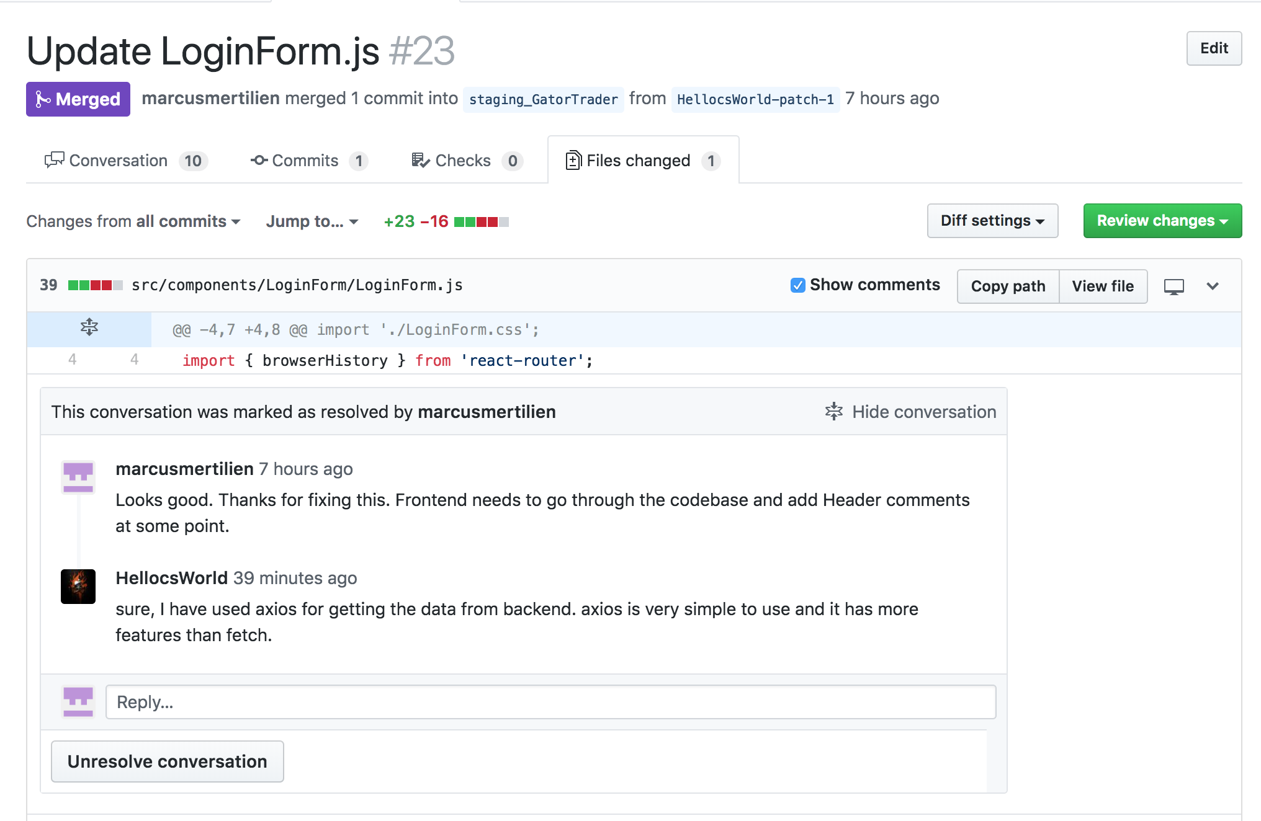

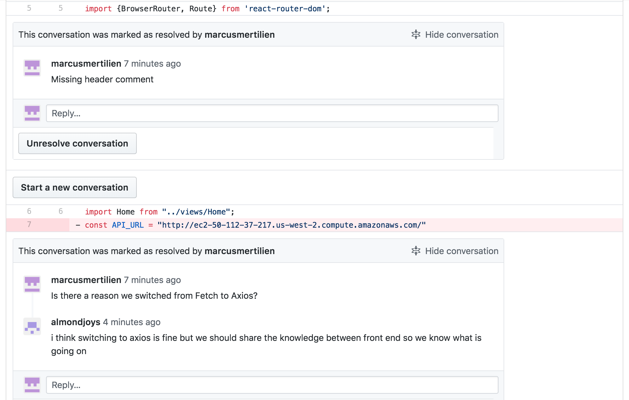

**Reviewed Code Snippet**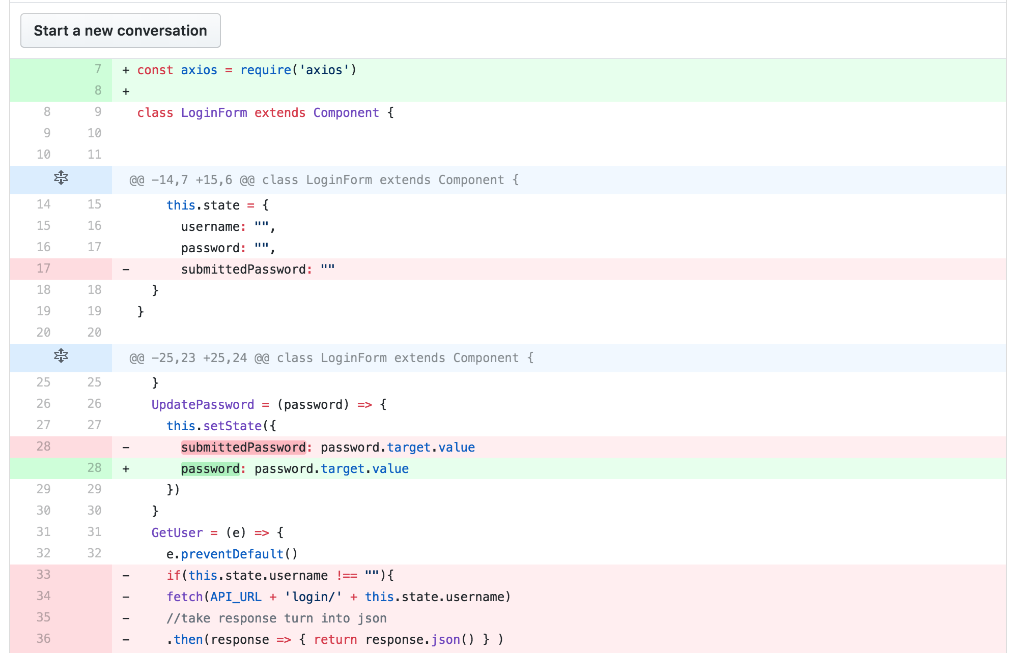

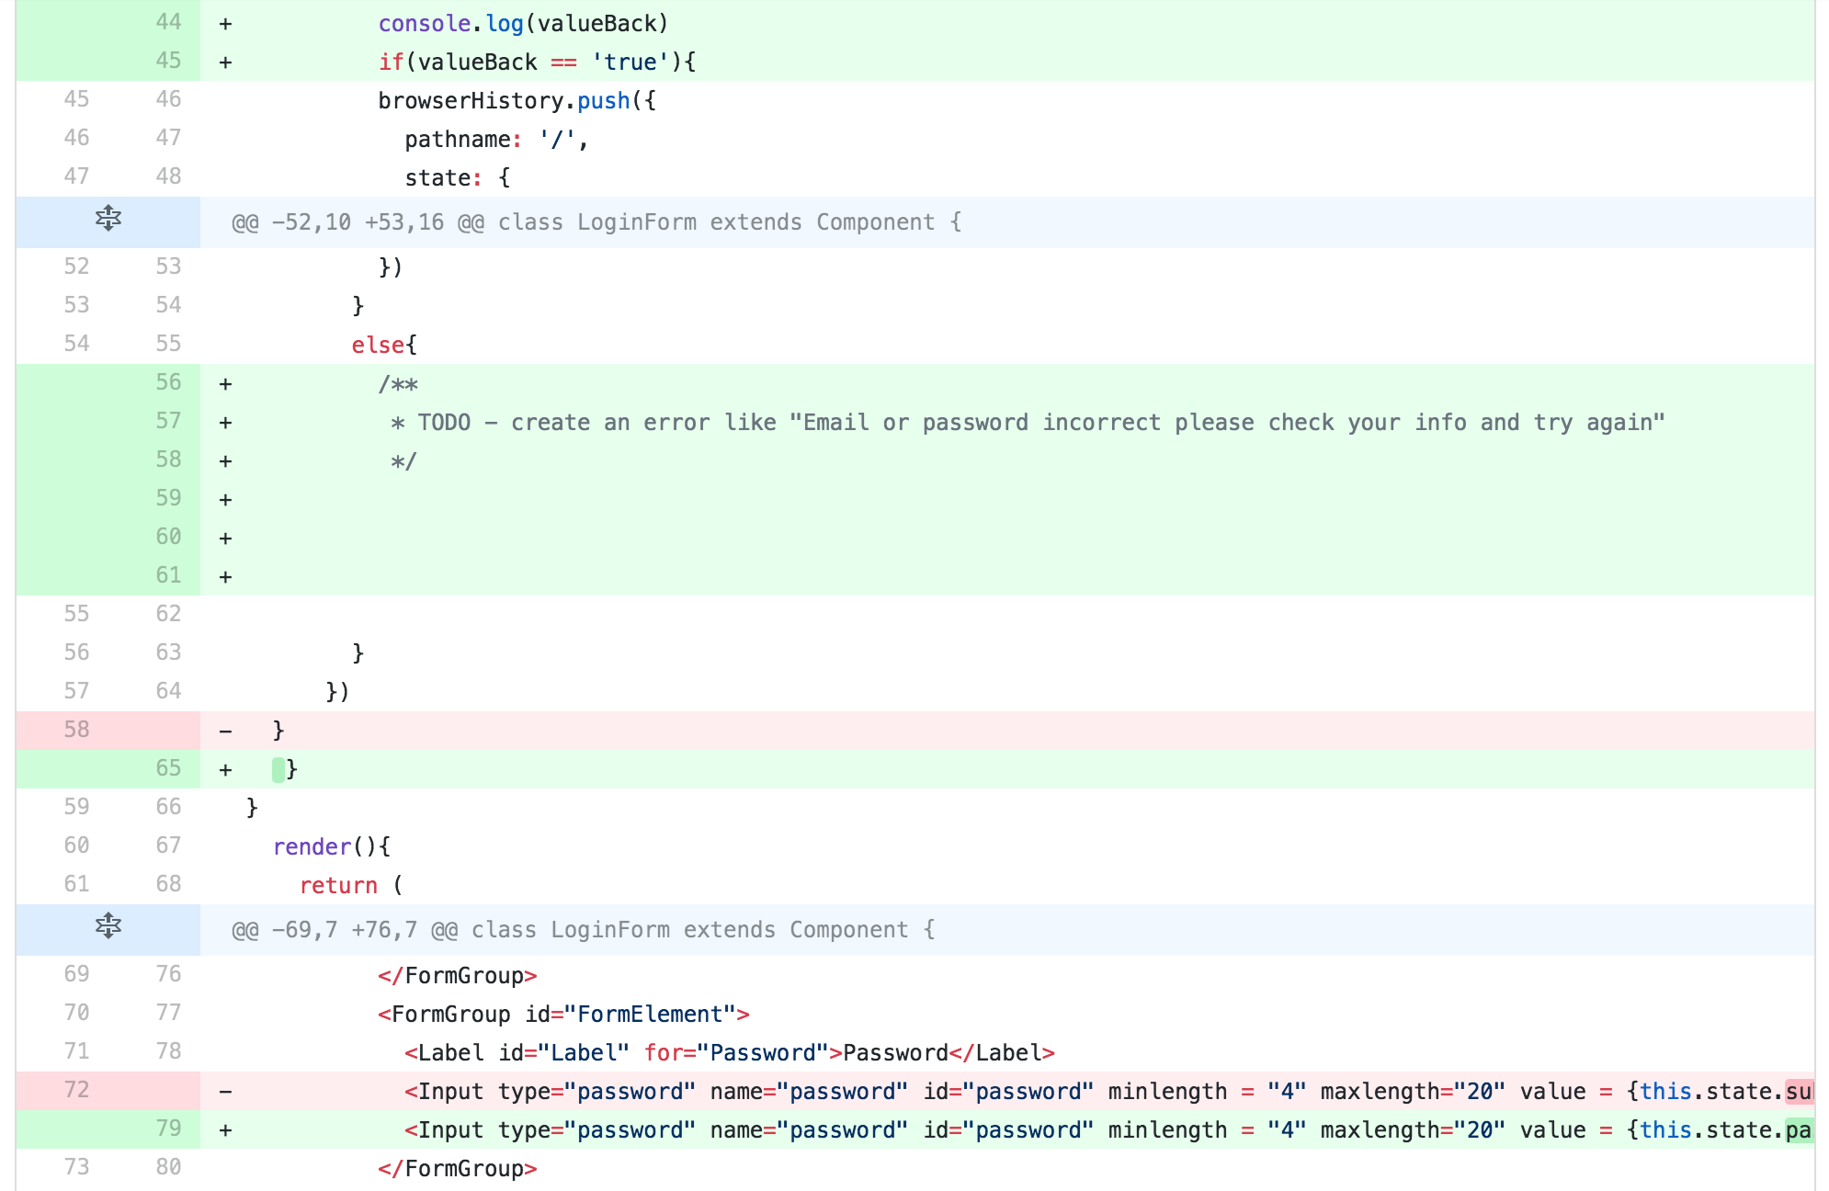

**5) Self-check on best practices for security**

***5.1 Major Assets Being Protected***

The following user information is being protected:

* Name
* Password
* Email address
* Listing address
* Sales Items

***5.2 Encryption of Passwords in the Database***

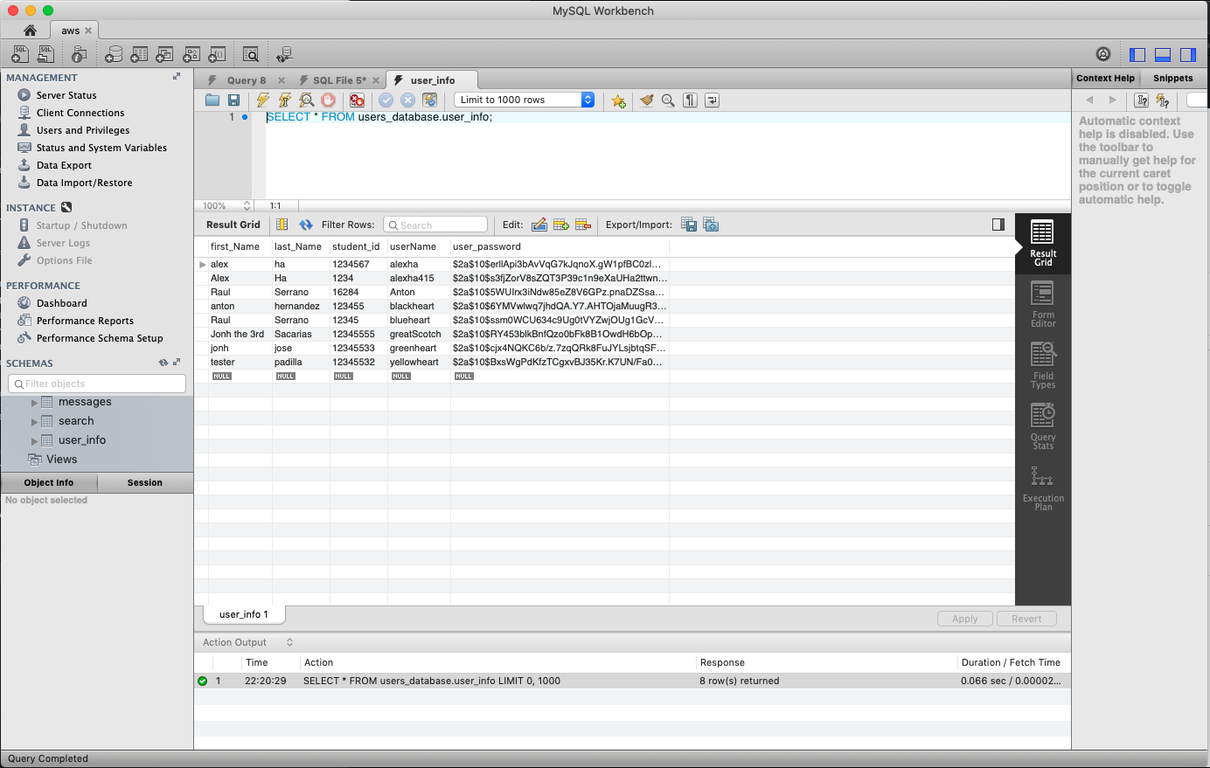

**5.3 Input Data Validation**

The following user input is checked for validation on the front-end by built in html validation and bootstrap for registration, login and posting.

Listing details:

* Price
* Description
* Name of the item

Search query input:

* For example, if a user attempts to search “jgdfuhdkghdlfghlikhsgkhgkjehrkfghierkhekrhgerhtkjerhjerbjerjthbjerbtjerb”, the field will only take up to 40 characters.

**6) Self-check: Adherence to original Non-functional specs**

|  |  |  |
| --- | --- | --- |
|  | **Non-Functional Spec** | **Status** |
| 1. | Application shall be developed using React, Heroku, Express, MySQL. | DONE |
| 2. | Application shall be designed for desktop and laptops. The browsers that support it are Chrome, Mozilla, and Internet Explorer and Opera. | DONE |
| 3. | Application shall render well on mobile | ON TRACK |
| 4. | Data will be stored on MySQL. | DONE |
| 5. | No more than 50 users can access the website at a time. | ON TRACK |
| 6. | Privacy of users shall be protected and all privacy policies will be appropriately communicated to the users. | ON TRACK |
| 7. | The language used shall be English. | DONE |
| 8. | Application shall be very easy to use. | DONE |
| 9. | Google analytics shall be added | ON TRACK |
| 10. | No E-mail clients shall be allowed | DONE |
| 11. | No pay functionality only messages. | DONE |
| 11. | The website will display “SFSU-Fulda Software Engineering Project CSC 648-848, Fall 2018. For Demonstration Only” at the top of the page. | ON TRACK |

Product Screen Shots

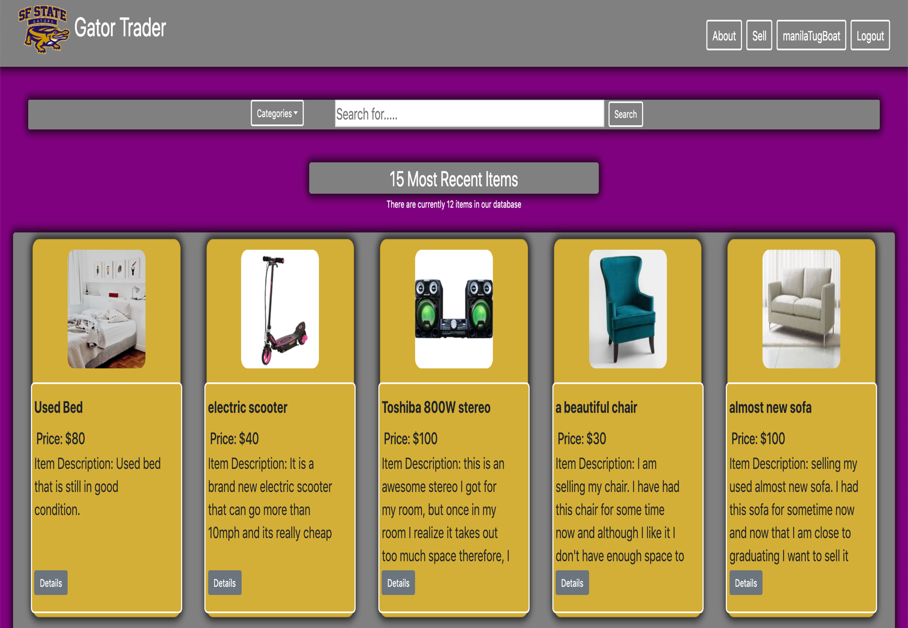

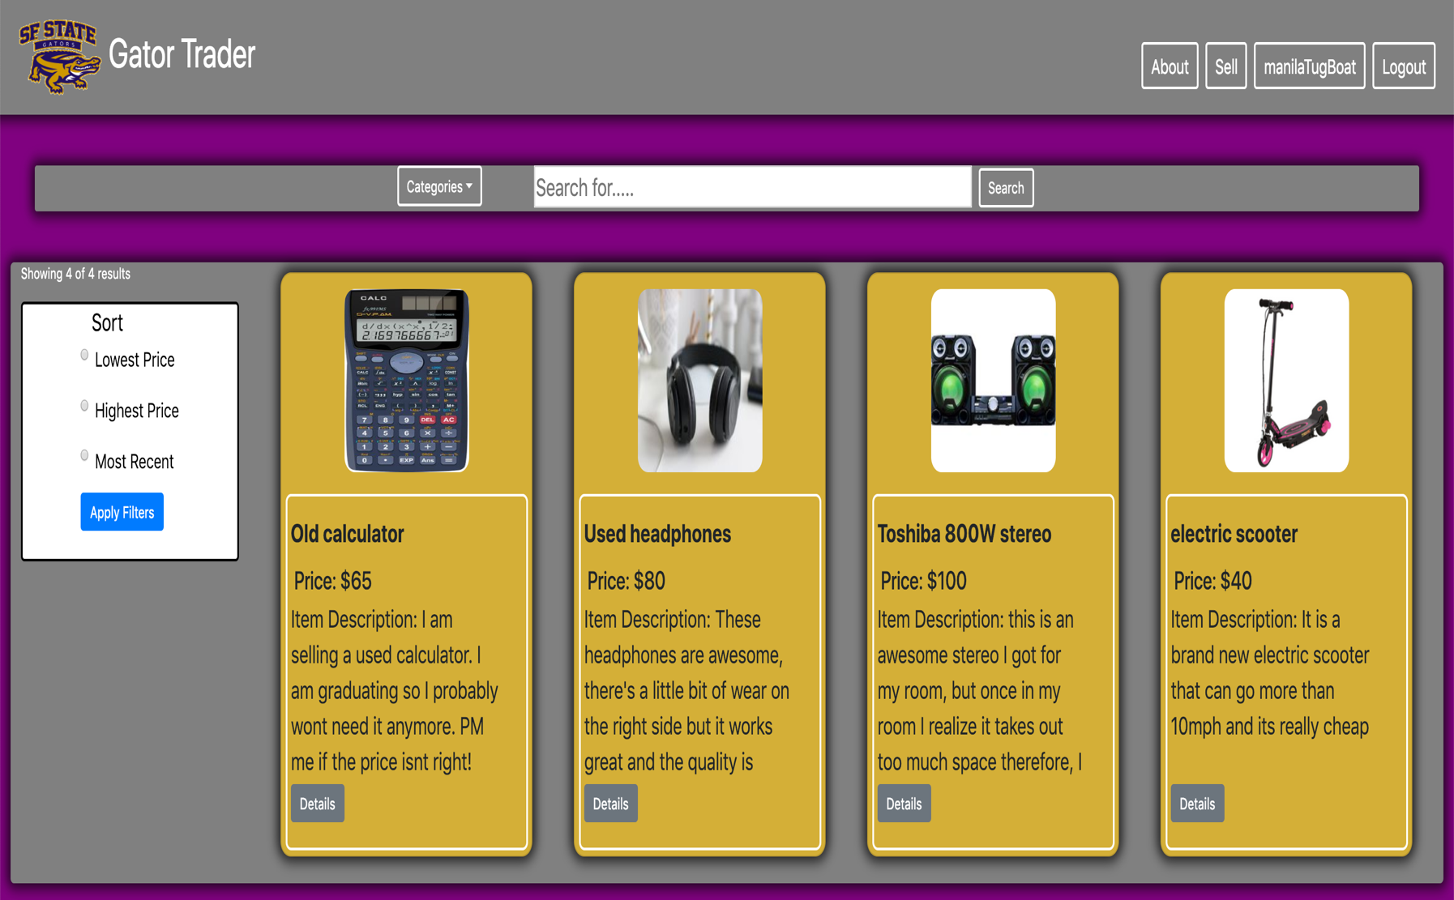

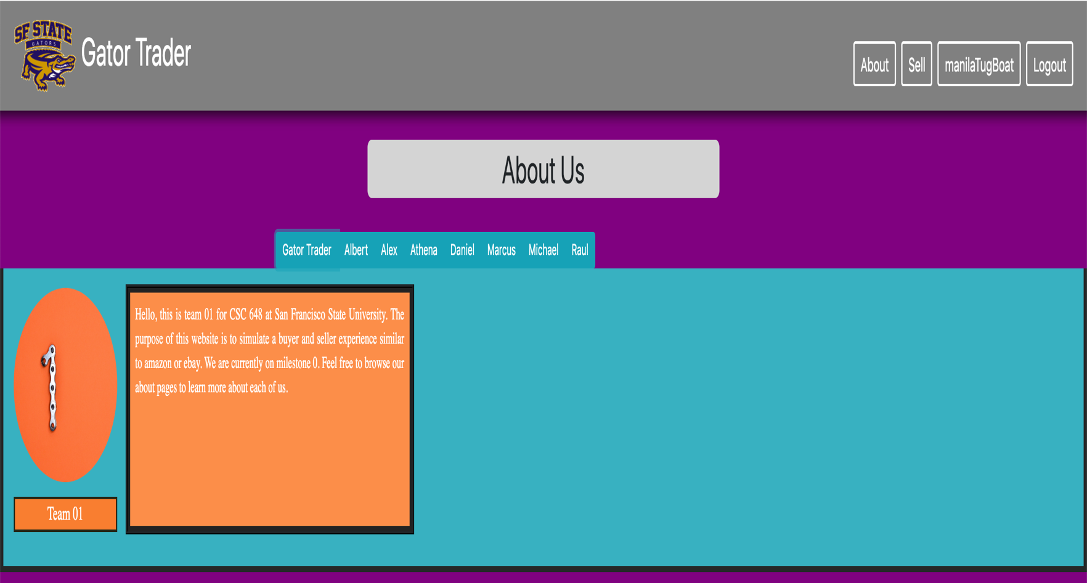

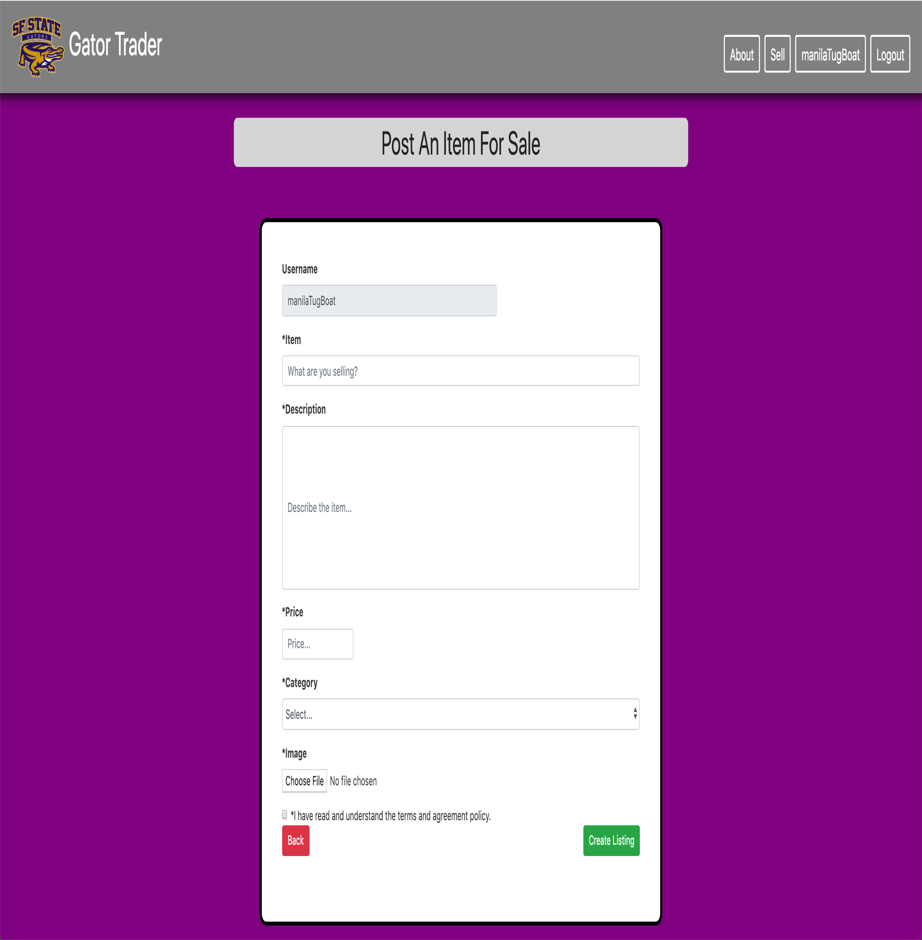

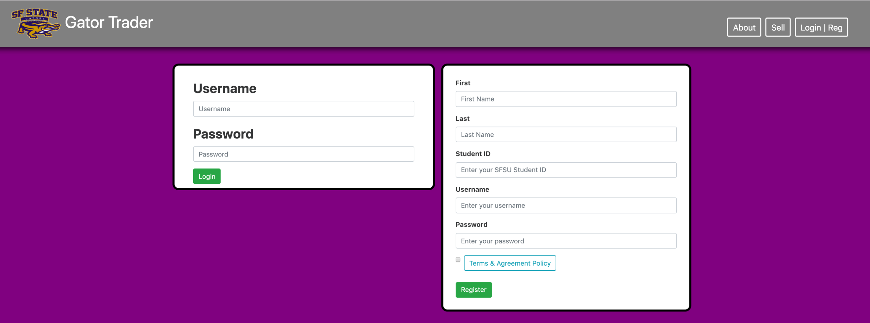

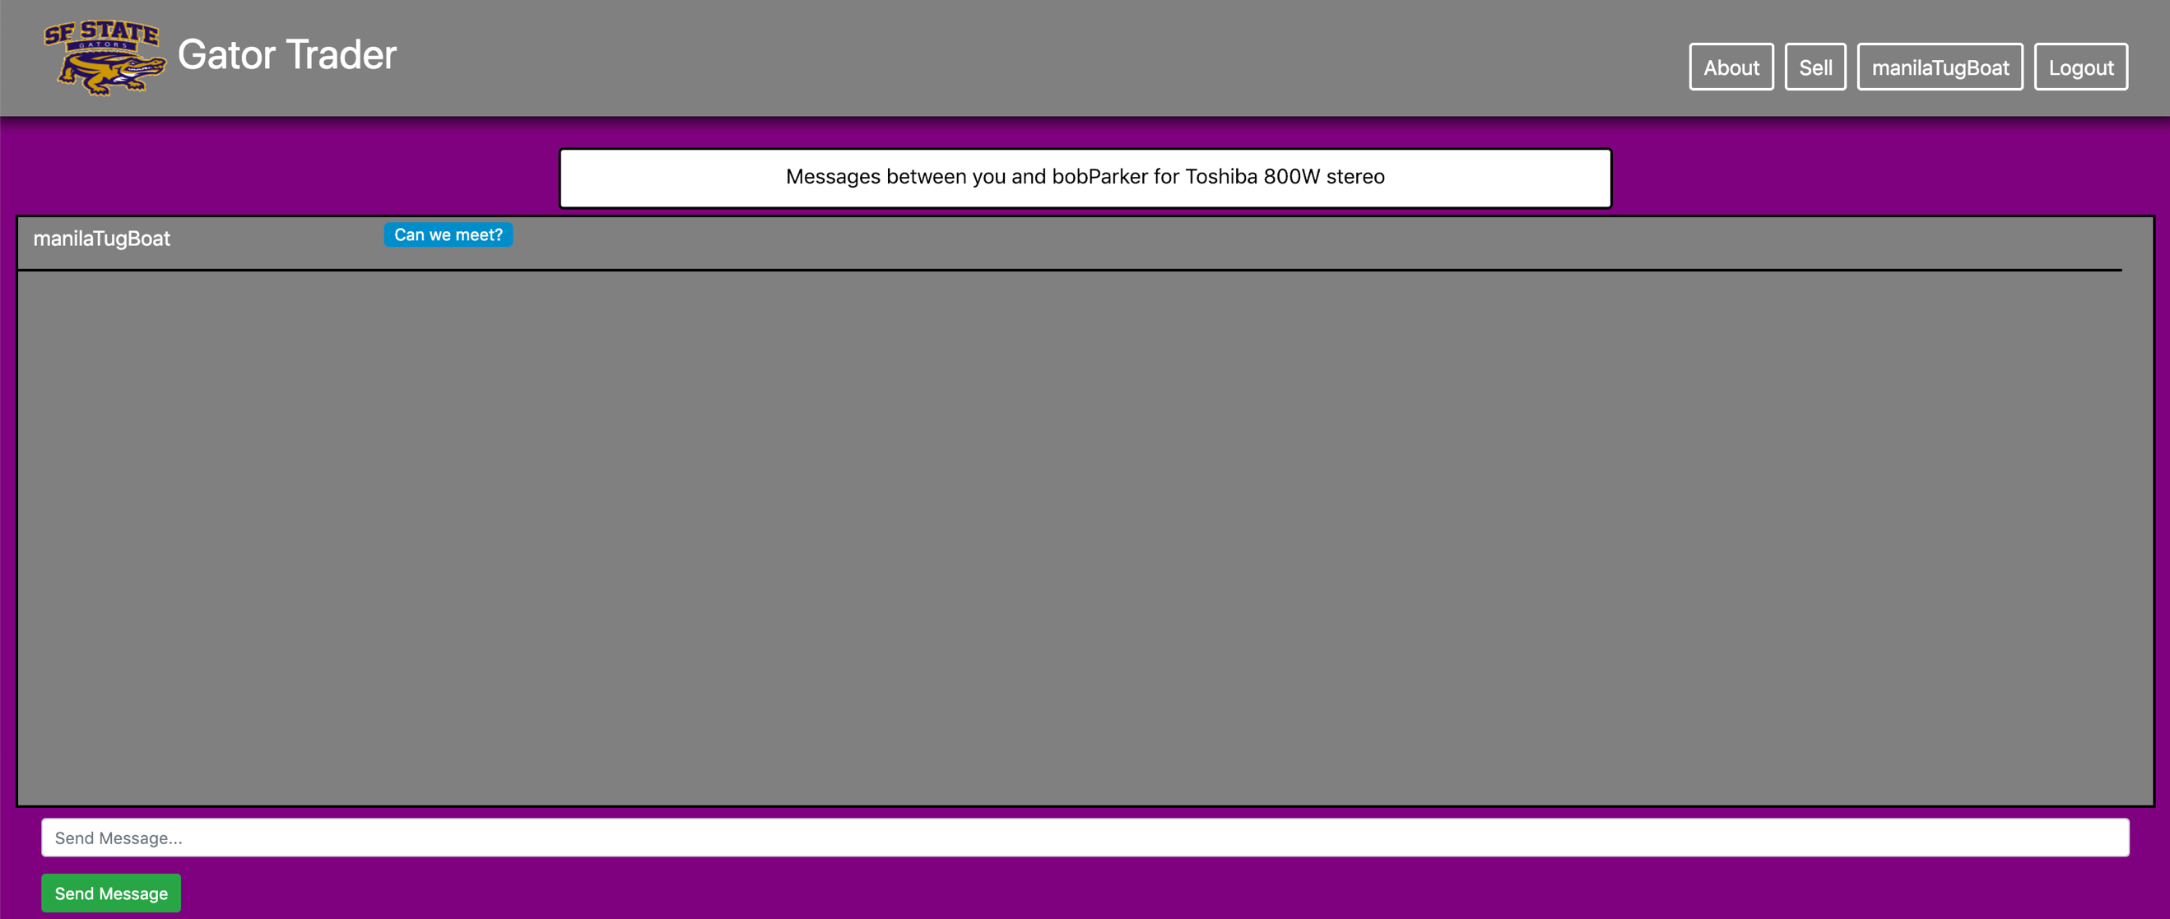

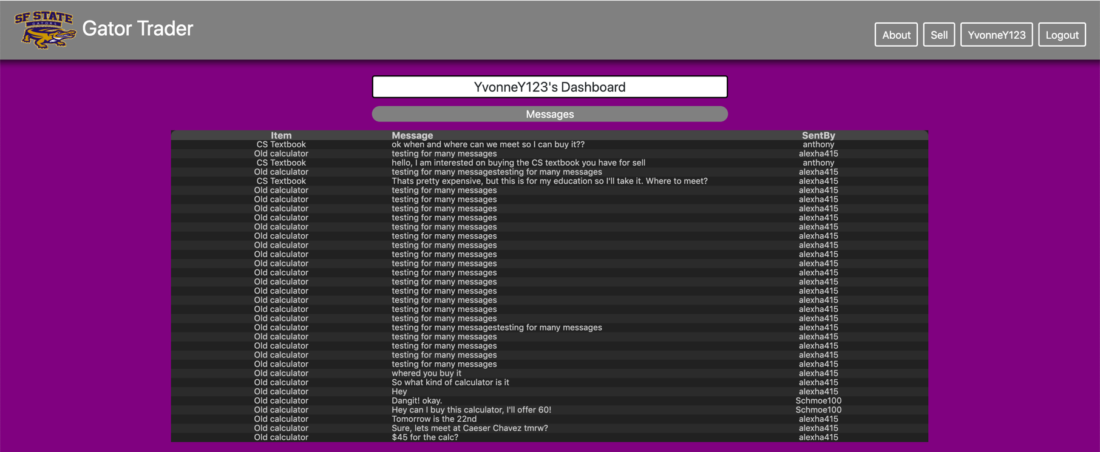

**Key Database Tables**

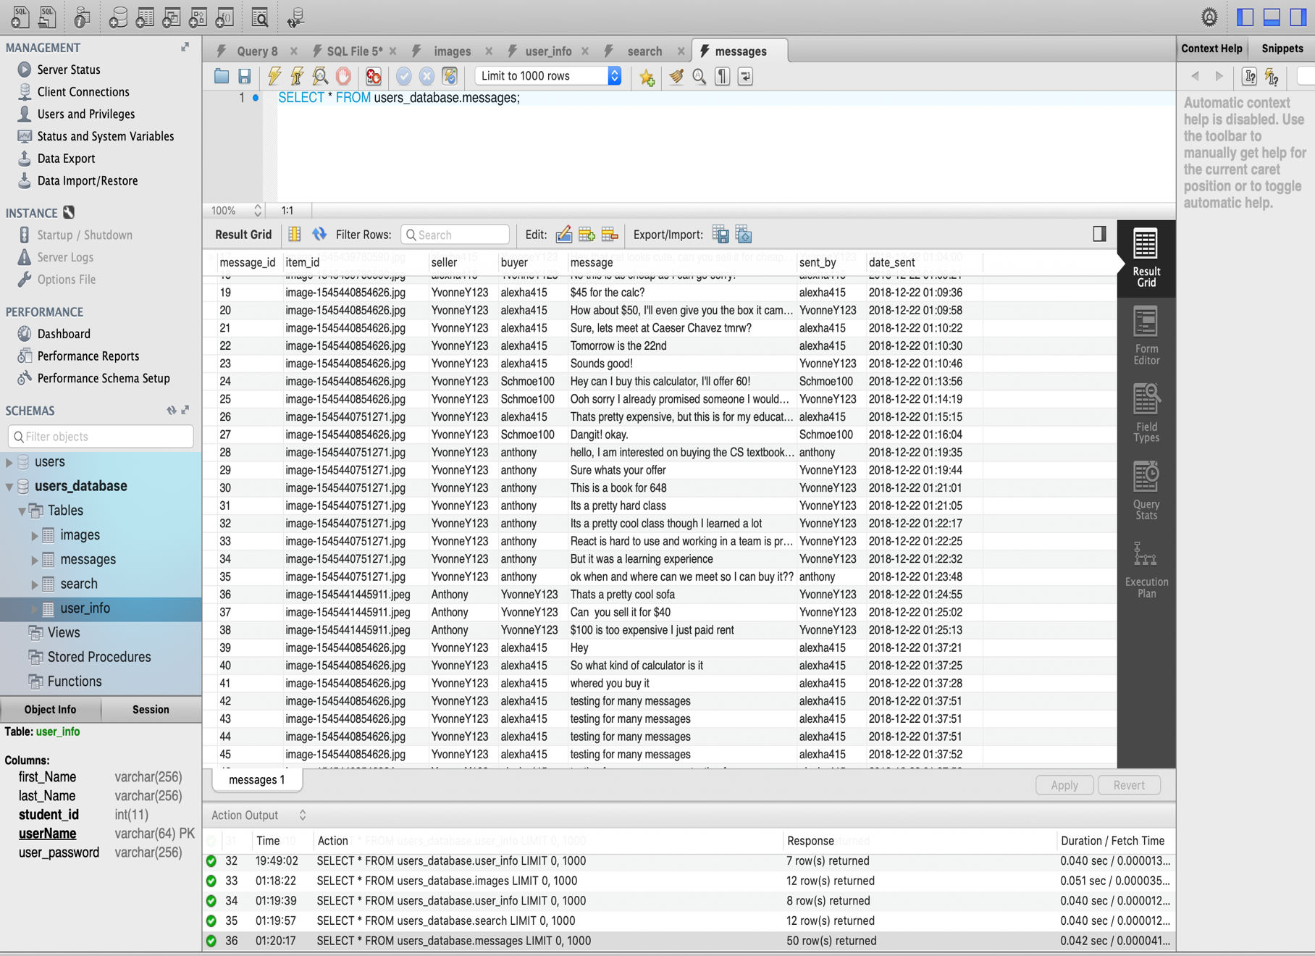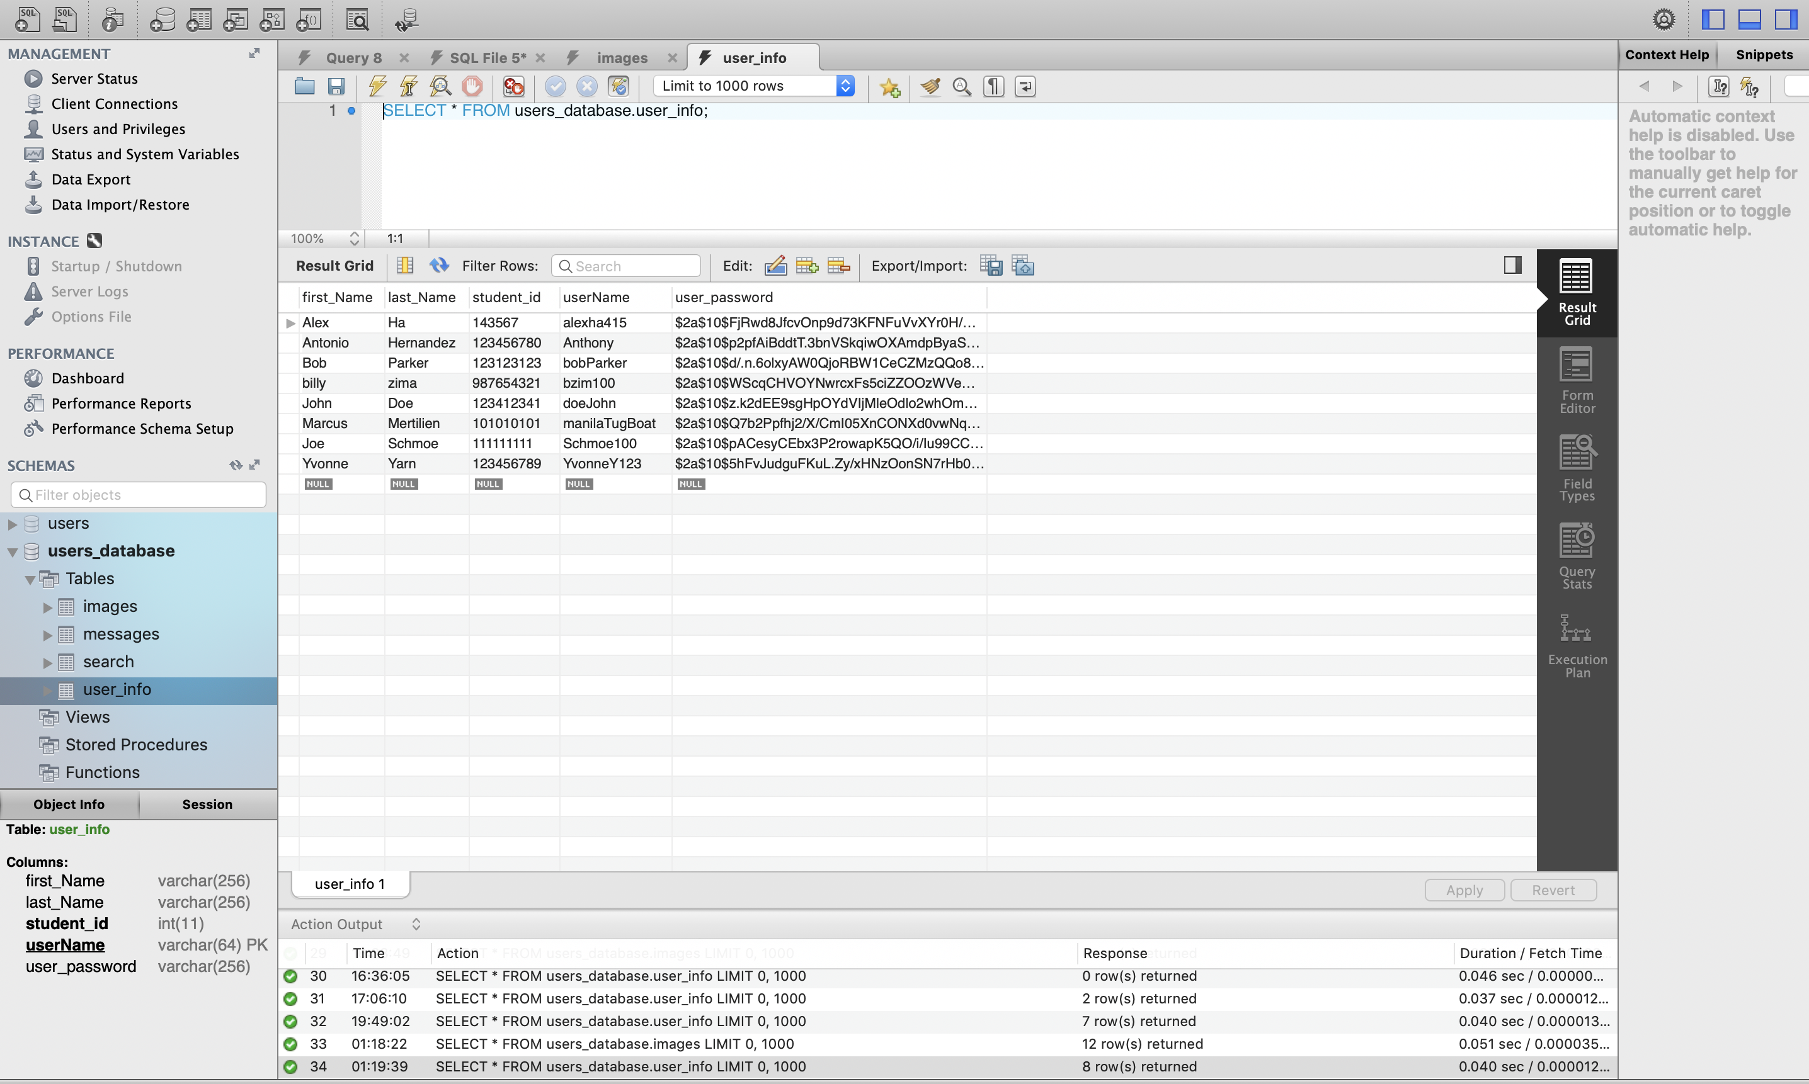

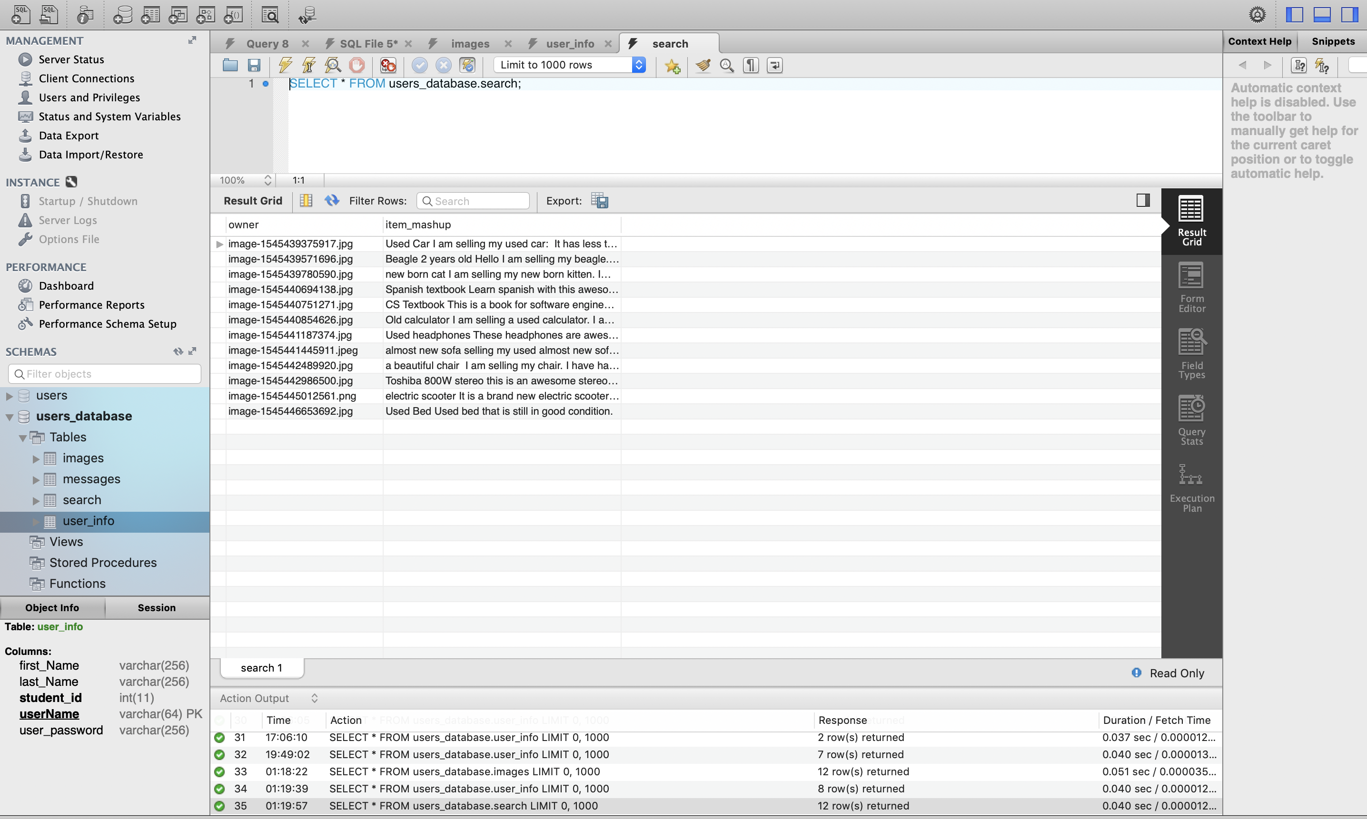

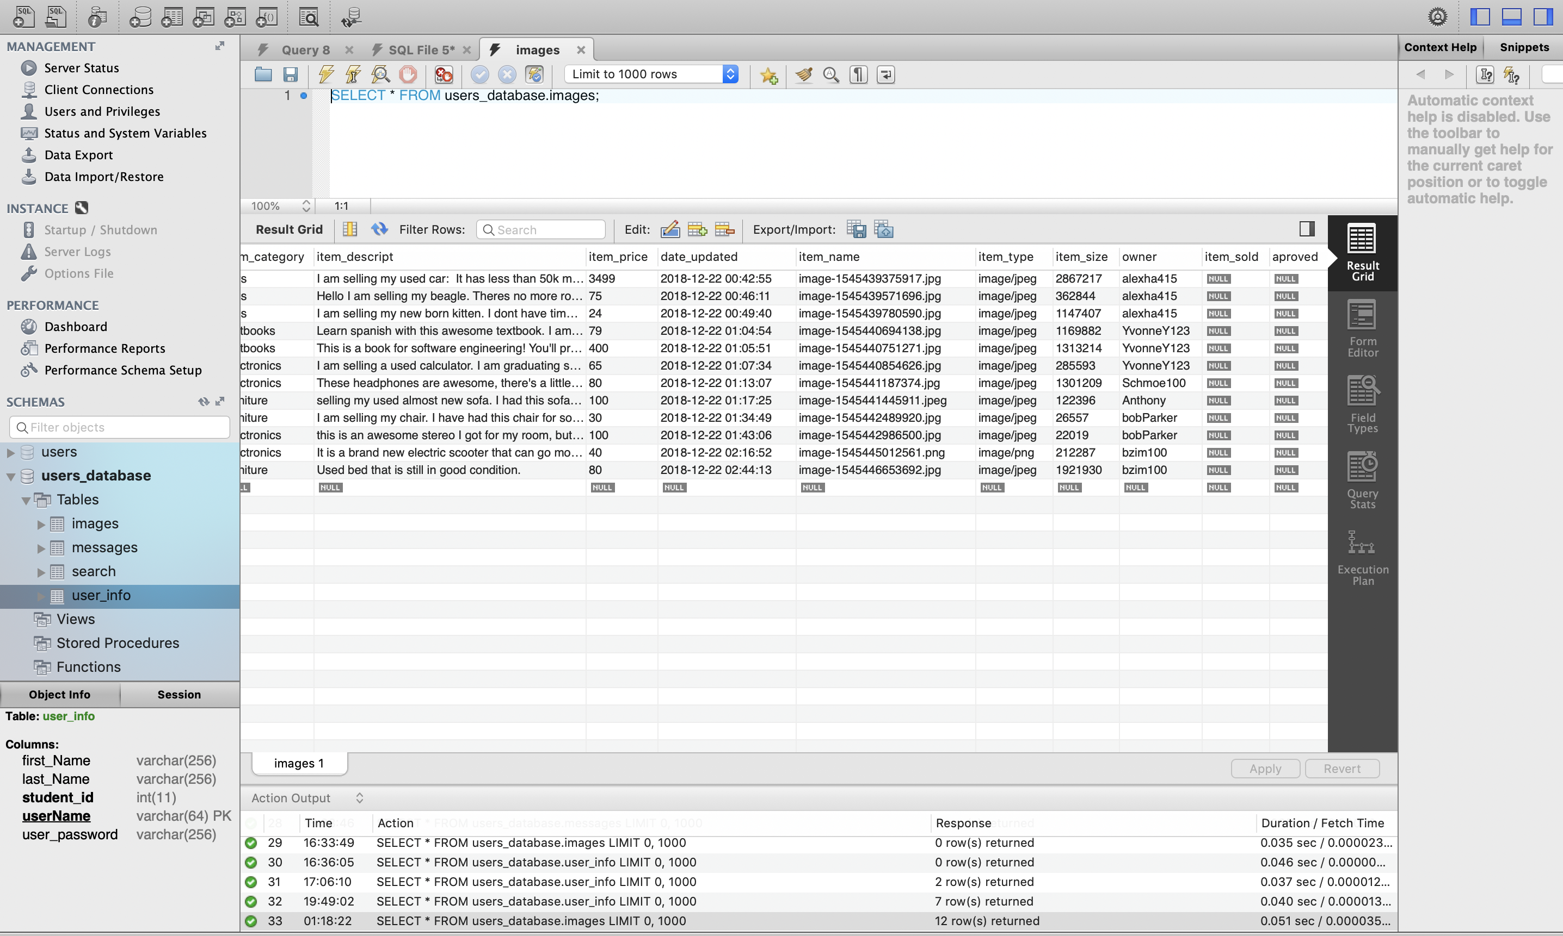

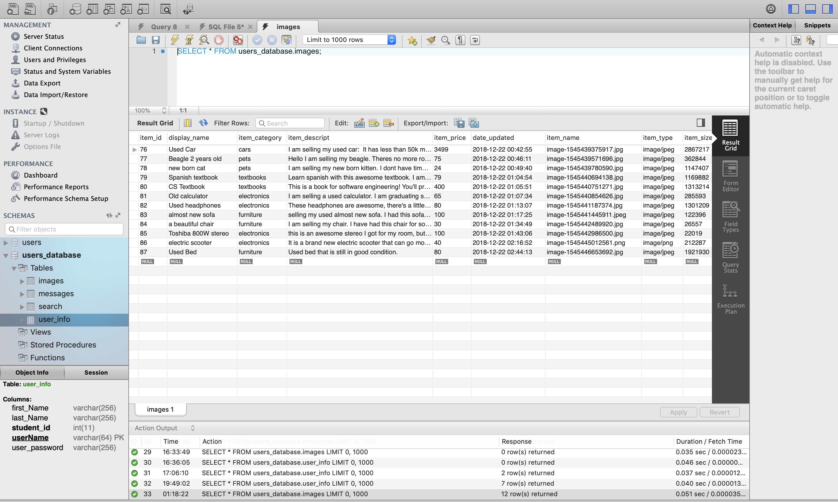

**Google Analytics**

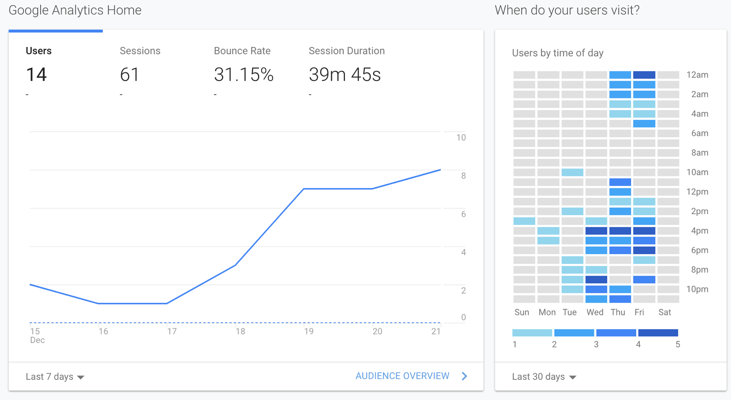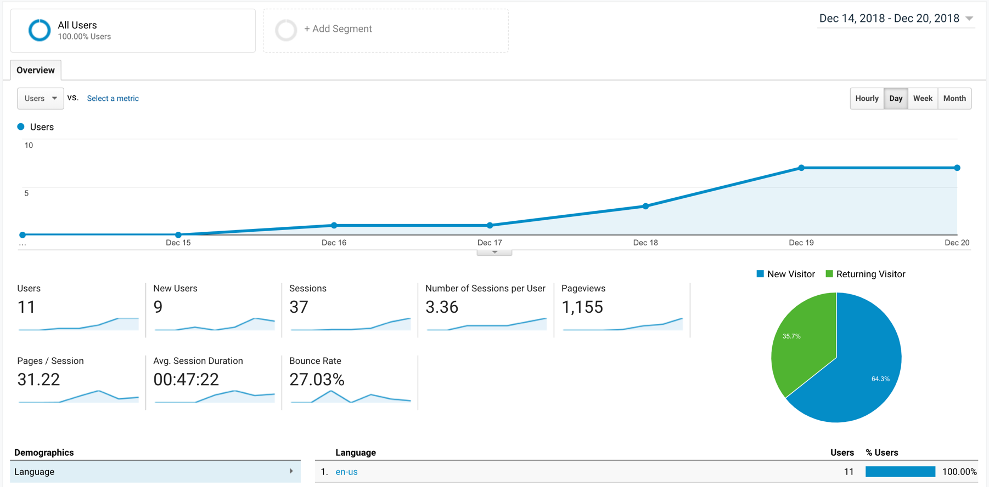

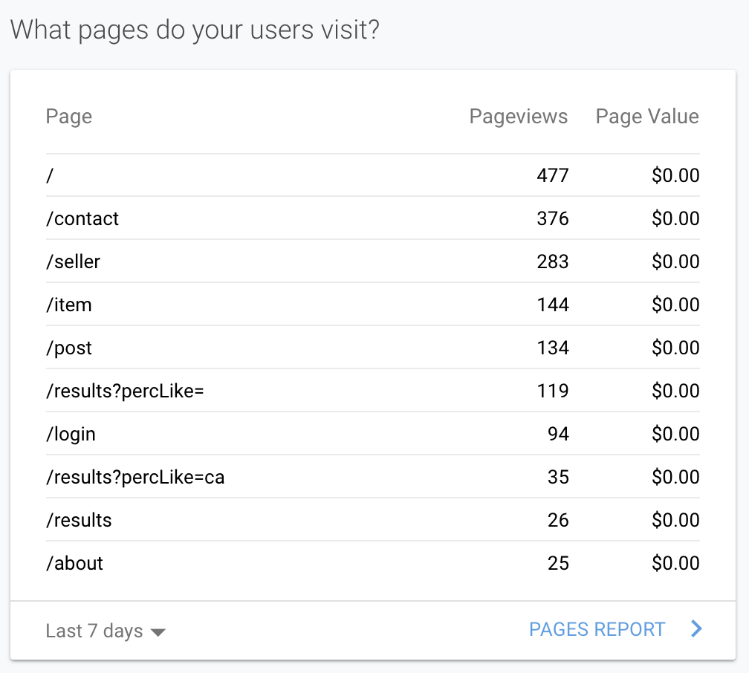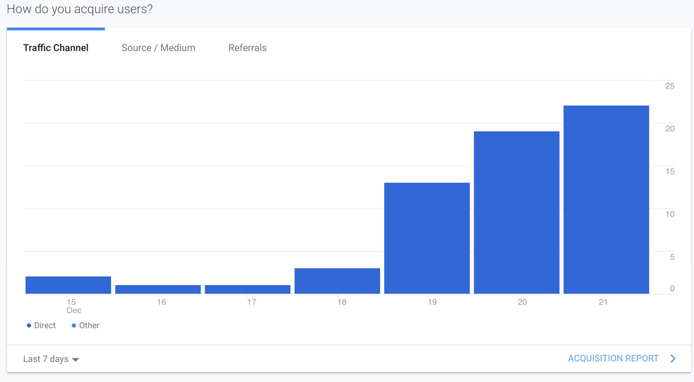

**Team Member Contributions**

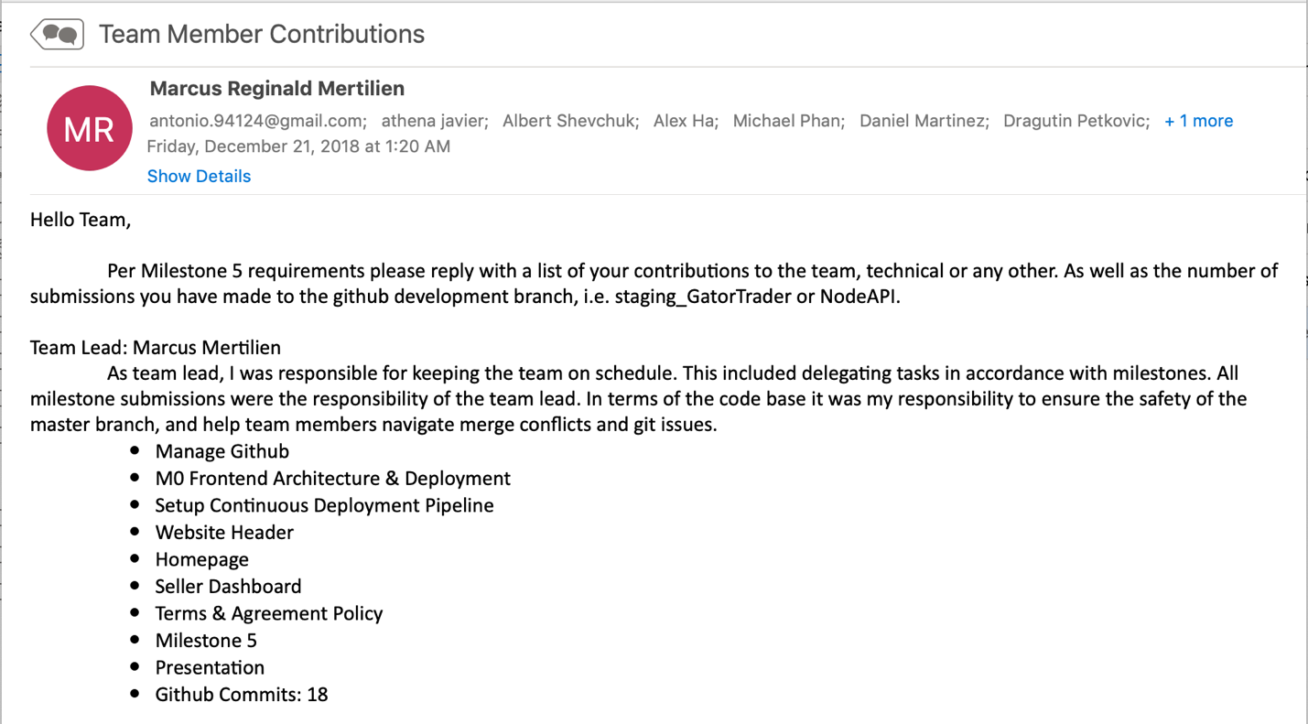

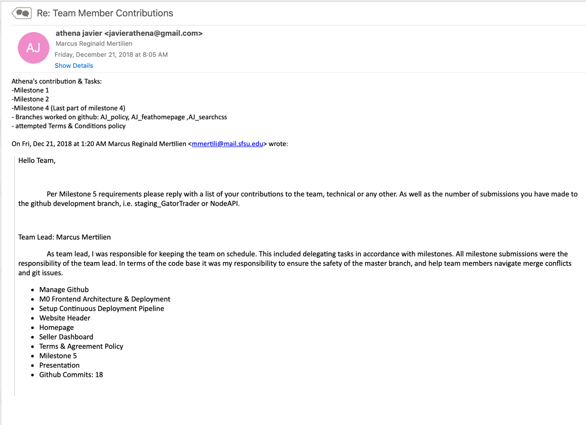



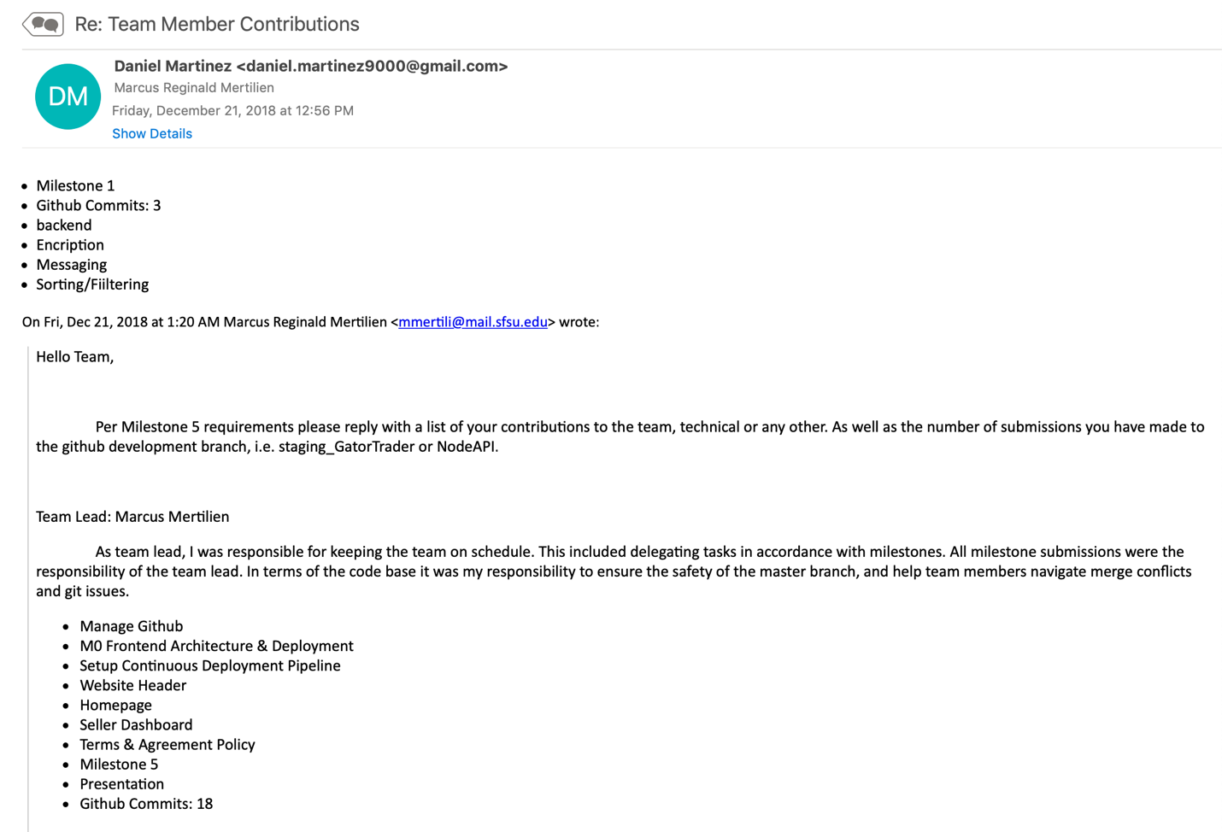

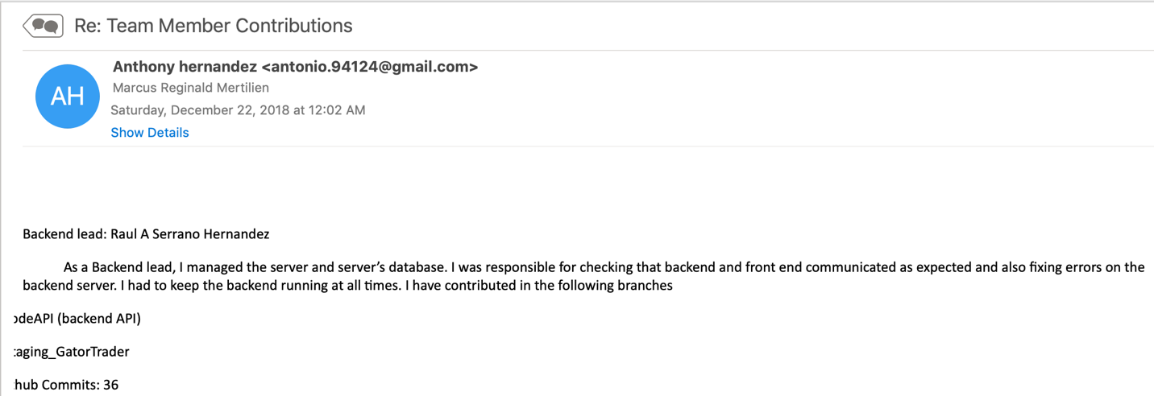

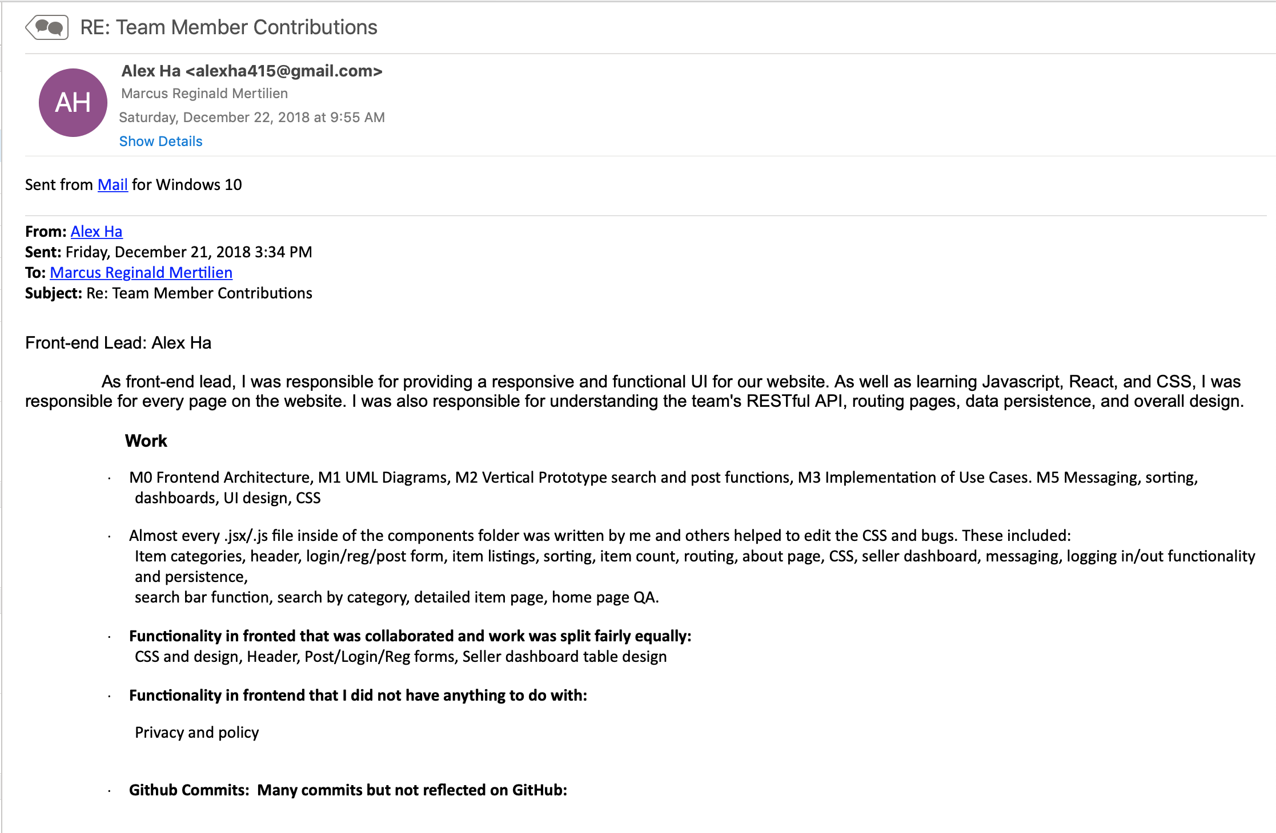

**Post Analysis**





